EC2 Lab Assignment

1. Launching EC2 Instance

1. Download Putty.exe and Puttygen.exe
2. Click on EC2 services.

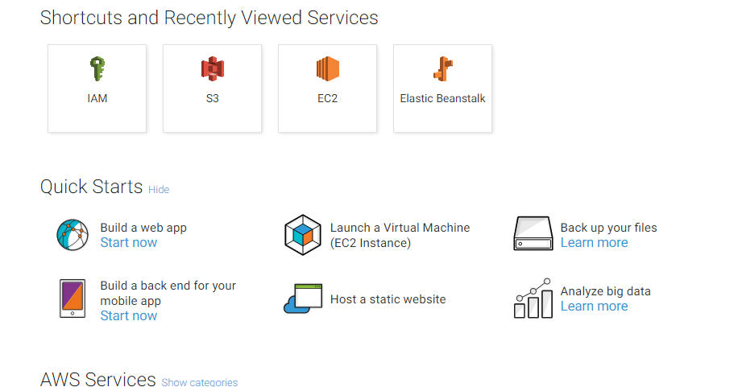

1. Click on Launch Instance to Choose the instance type and choose the Amazon Linux AMI

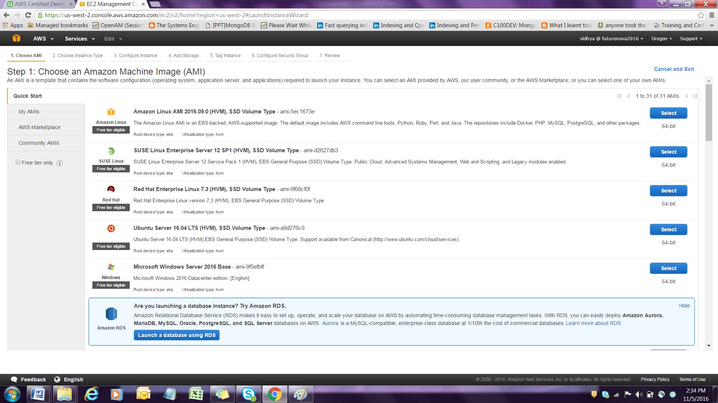

1. Choose instance type General Purpose T2 micro

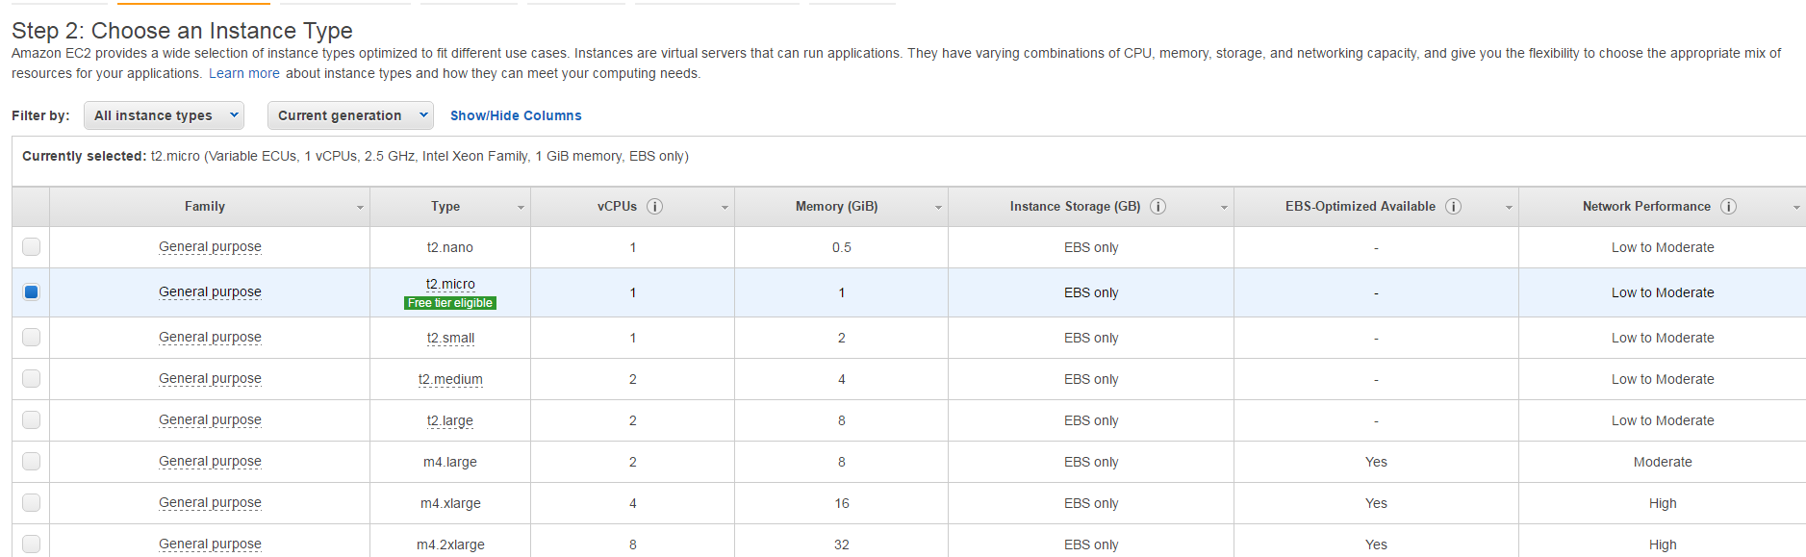

1. Click on next : configure Instance details

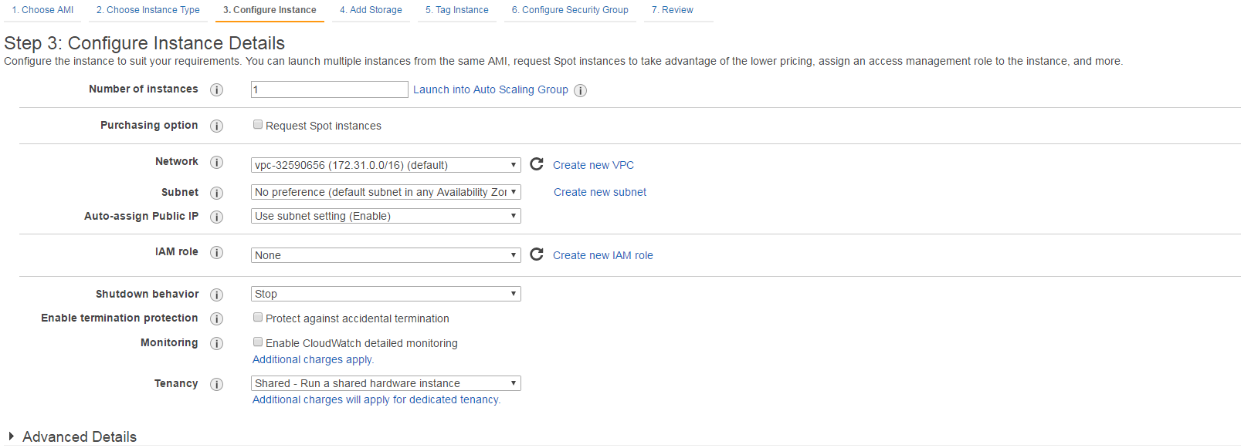

1. Click on Next : Add Storage

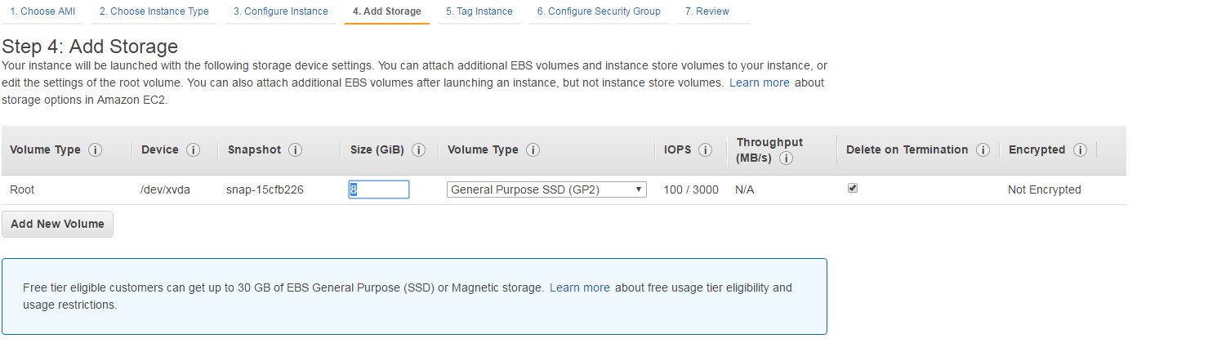

1. Click on tag instance option to associate a key value name to the instance.

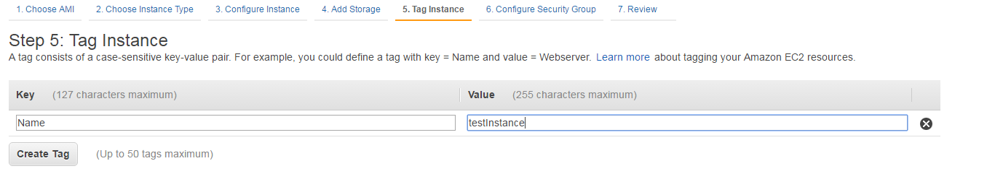

1. Click configure Security group

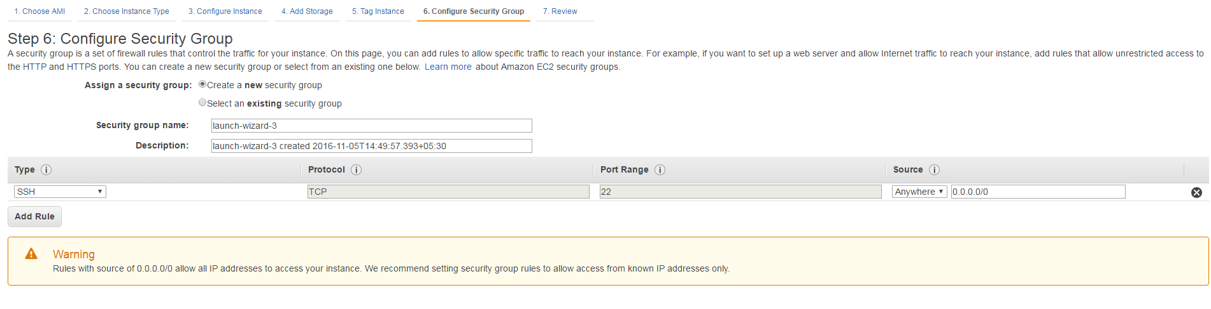

1. Click on Review and Launch





1. Choose a new pair of key called puttykey

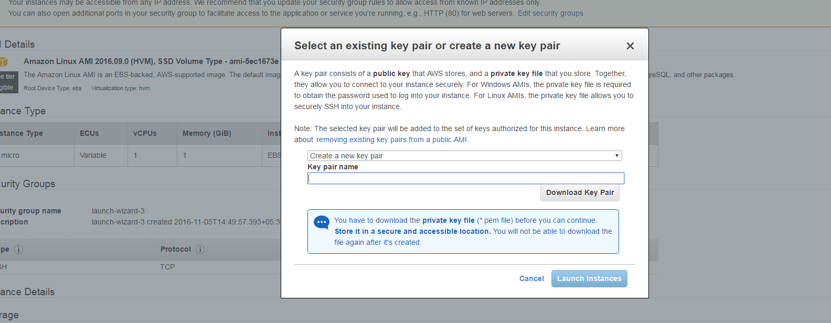

1. Click on Download key pair

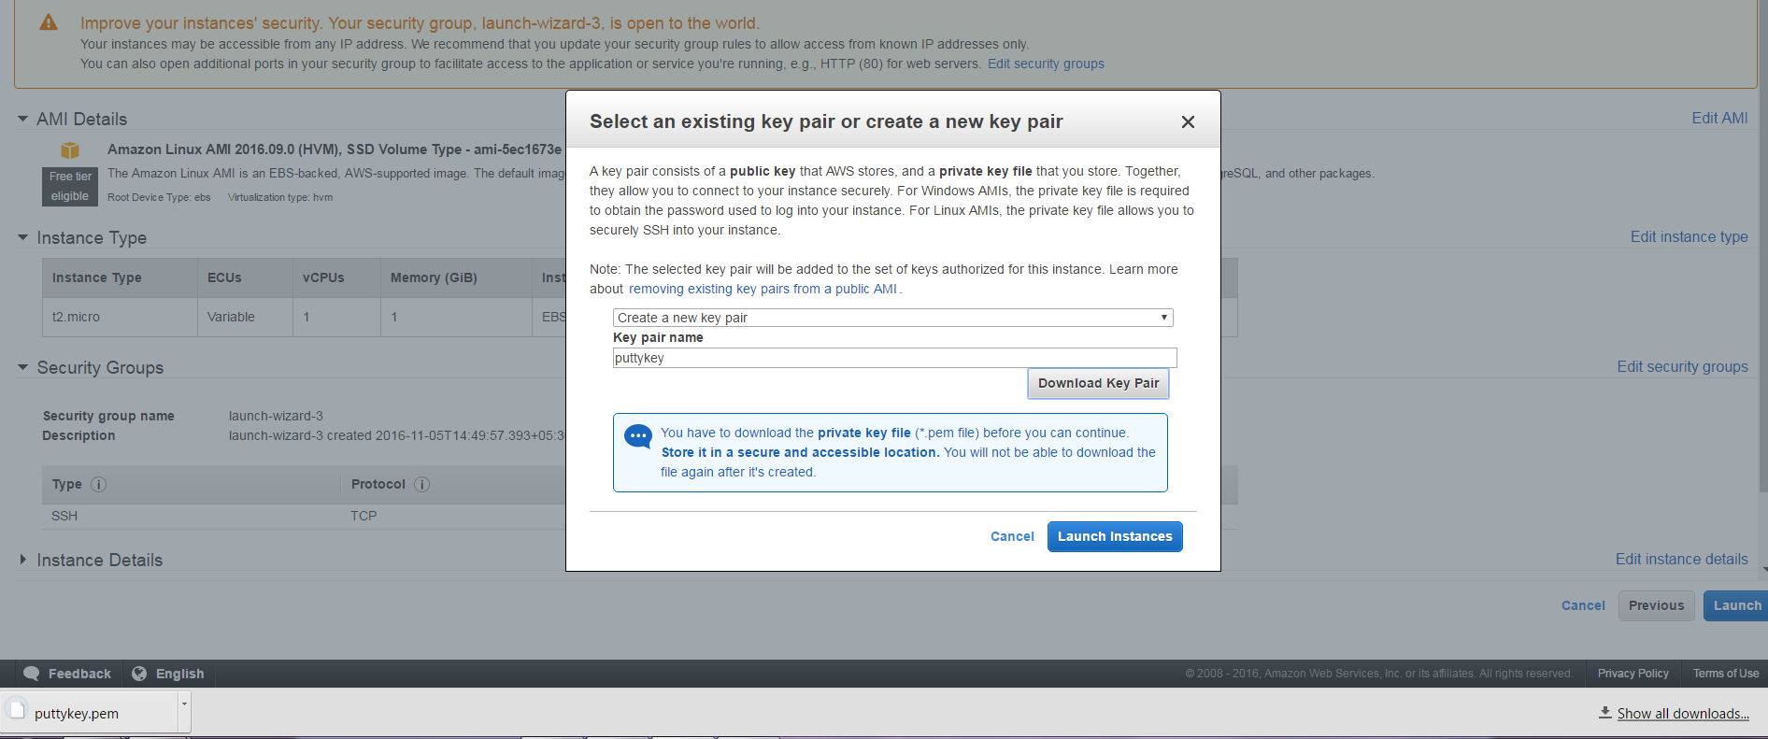

1. Click on Launch instance

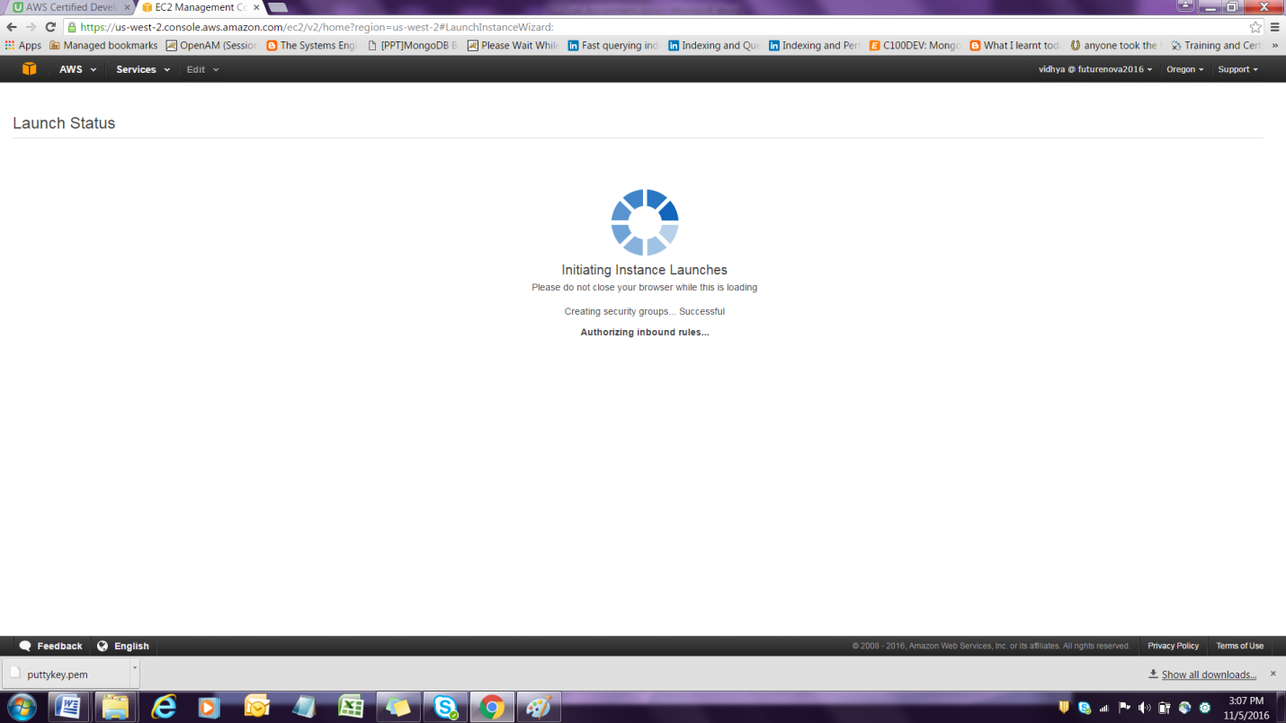

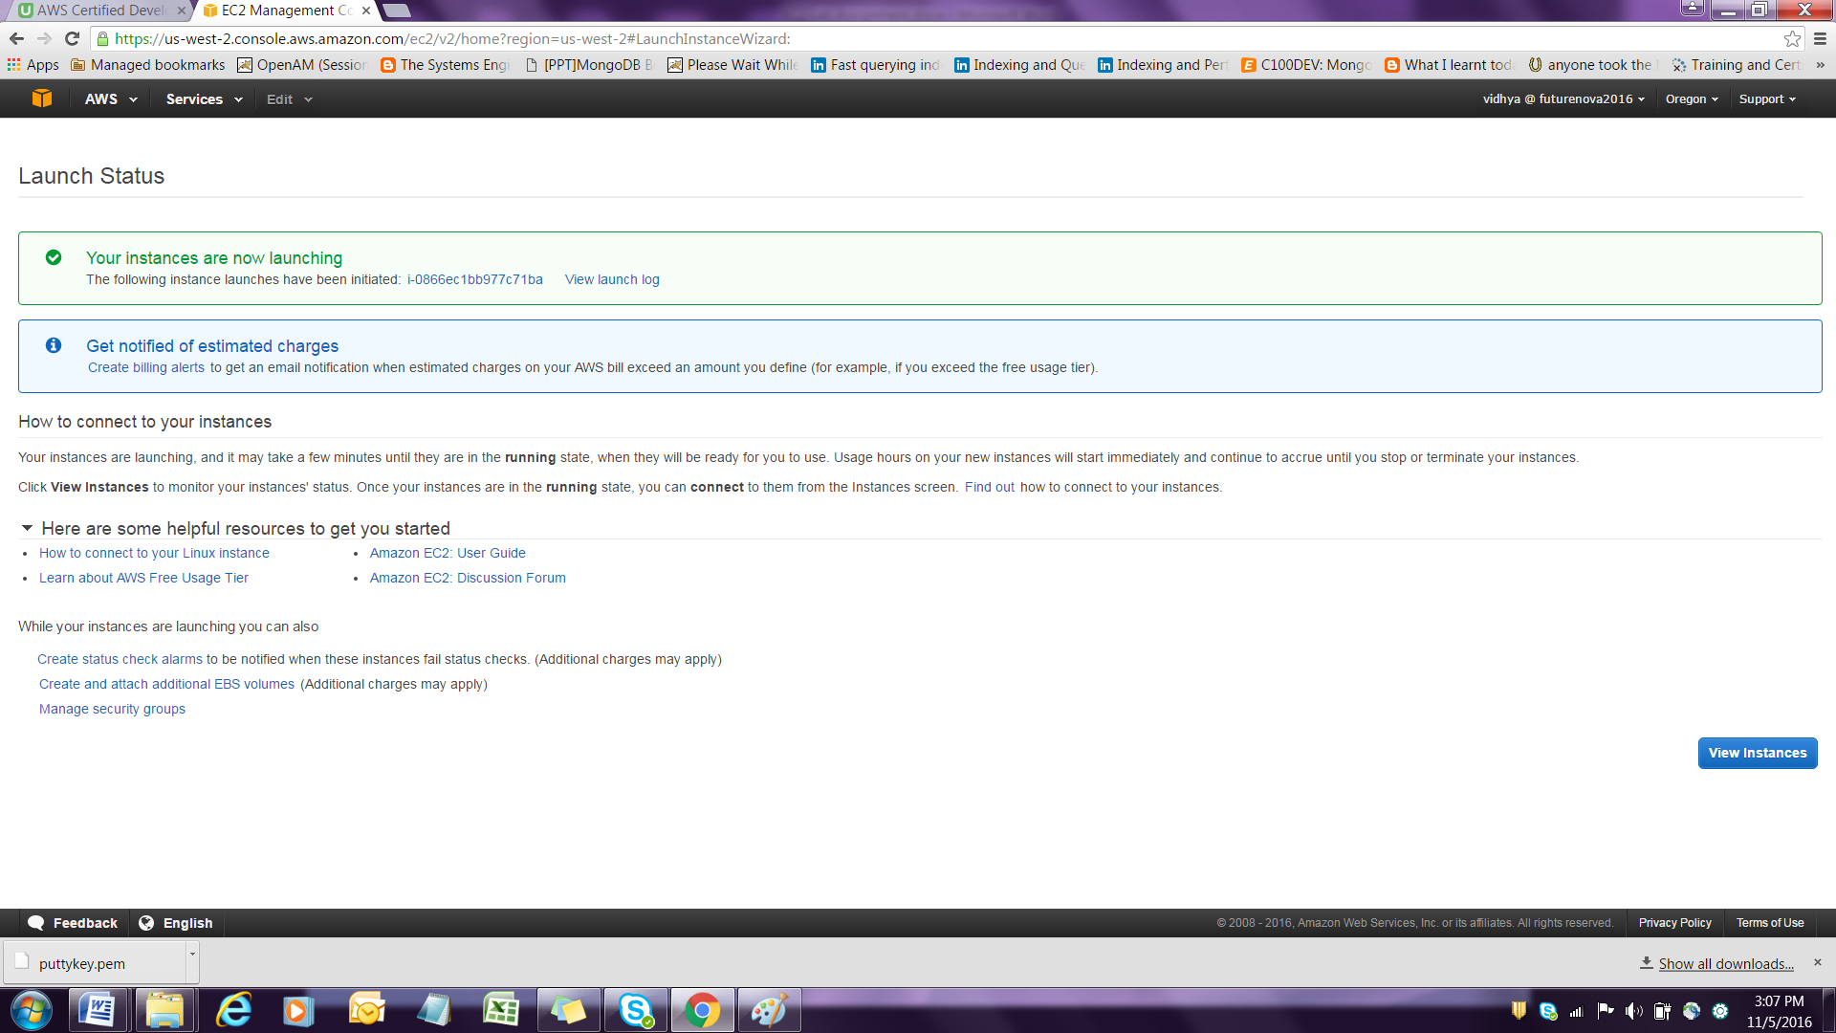

1. Go to D:\Users\srsenthi\Downloads , click on puttyGen utility and run it

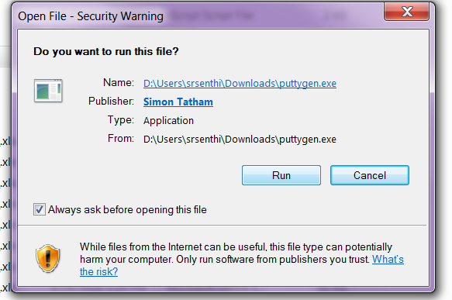

1. Click on Load to load an existing key file and choose the puttykey.pem by select All files.





1. Click on load option and click ok.

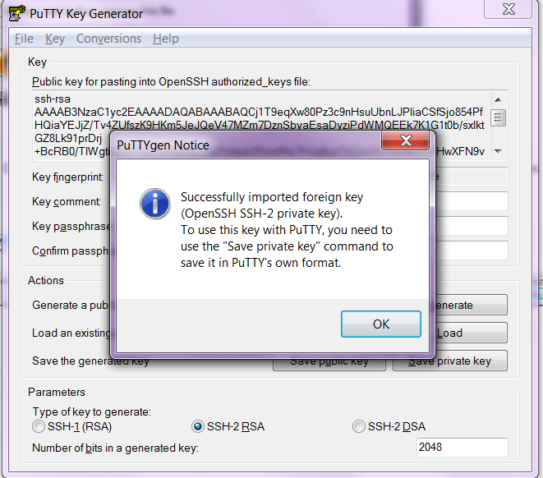

1. Click on Save private key.

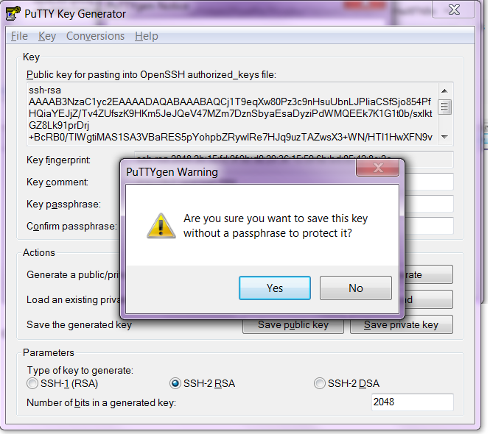

17. Click Yes and choose All files so that we can trace .pem file ,select the file and save it .





1. .Choose puttykey.pem and save it as puttykey.ppk and track it down in downloads folder .



19. Go to view Launch instance and click the instance running to view the IP

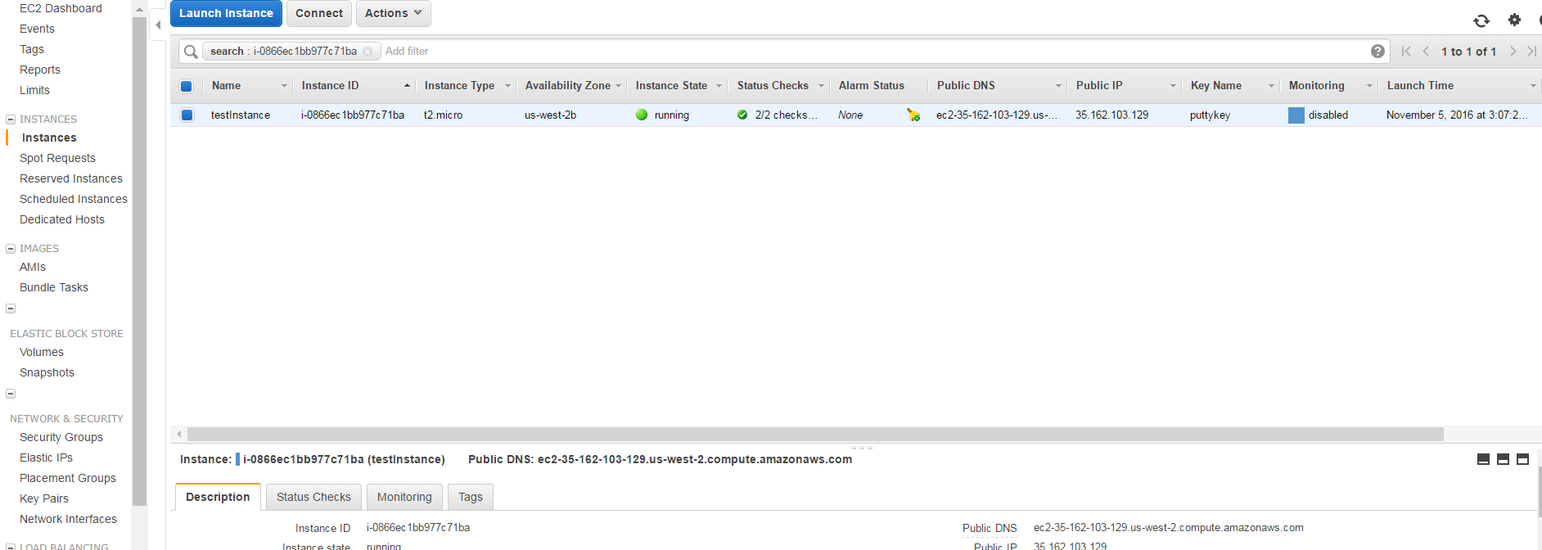

1. Click on Putty.exe and run it and give the IP as ec2-user@ 35.162.103.129

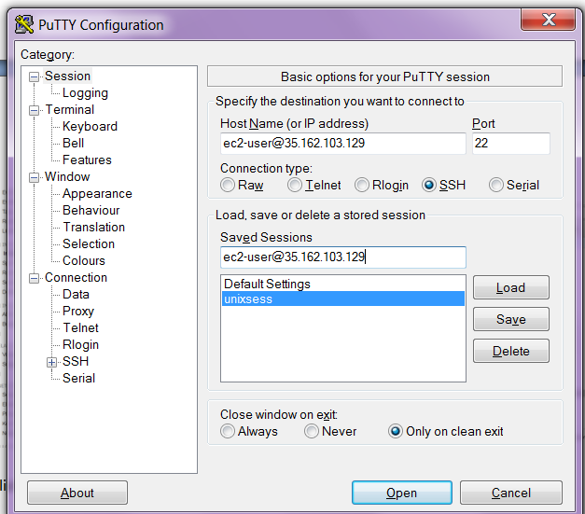

1. Click on SSH on left pane 🡪 Auth -🡪

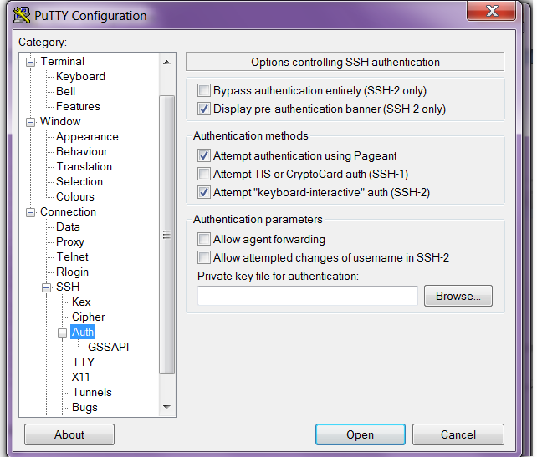

1. Click on Browse and choose the puttykey.ppk

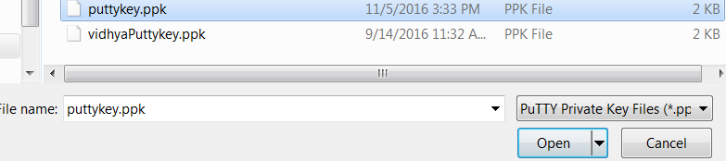

1. Click open and puttykey.ppk gets opened

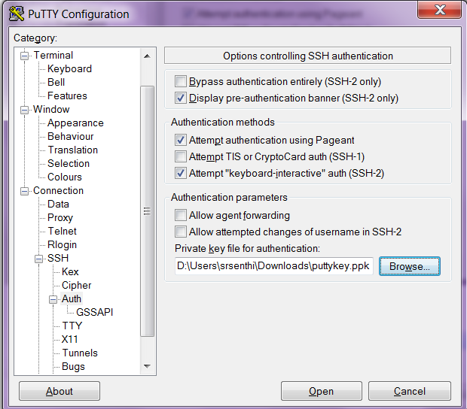

1. Click on Session on the left pane and click save sessions

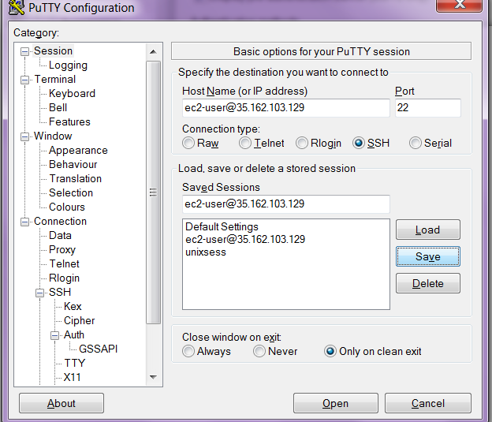

1. Click Load and open

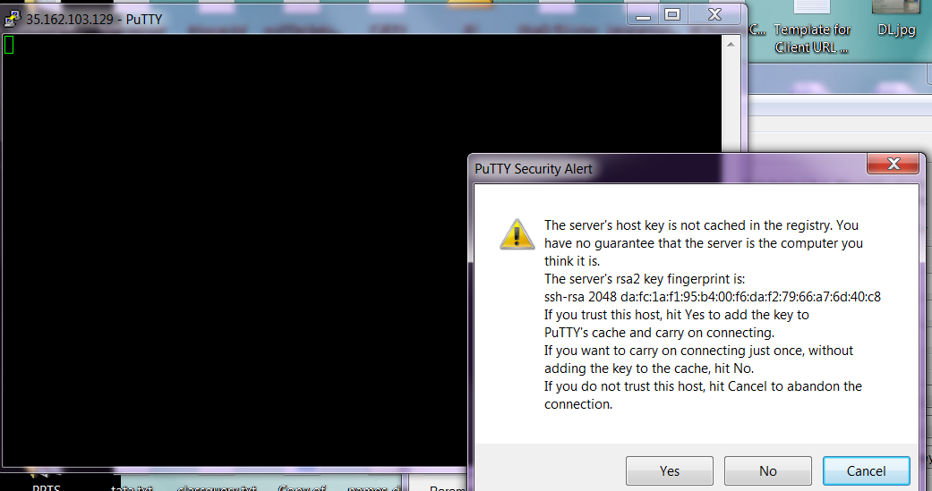

1. Click yes to connect to Ec2 instance.

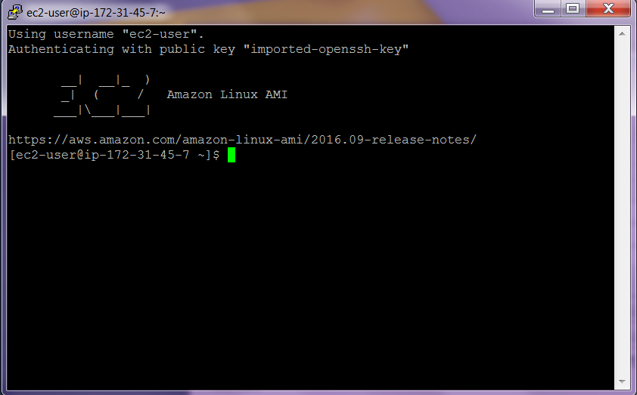

1. Type sudo su

Yum update –y to update EC2 instance

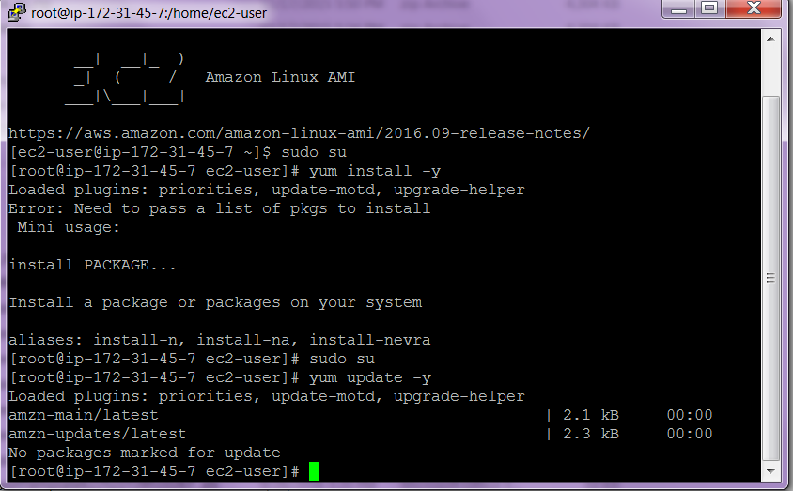

II**. Using user Credentials use CLI on EC2 instance and connect to S3**

**Follow the steps as already discussed in IAM to create user.**

**1. Create a user called tests3user.**

**2. Copy and paste the user credentials that is the Access key and Secret Access key in a notepad. Download the Credentials.**

**3. Create a new group called as TestS3group.**

**4. Attach the AmazonS3FullAccess to the group.**

**5. Add tests3user to the TestS3group.**

**6. Launch a new instance.**

**7. Connect to the Instance using putty.**

8. Type the following commands

] sudo su

]yum update –y

]aws s3 ls

Could not connect to endpoint …….

] aws configure

**Provide the access key, secret access key id and also the region as ap-southeast-1 when it prompts .**

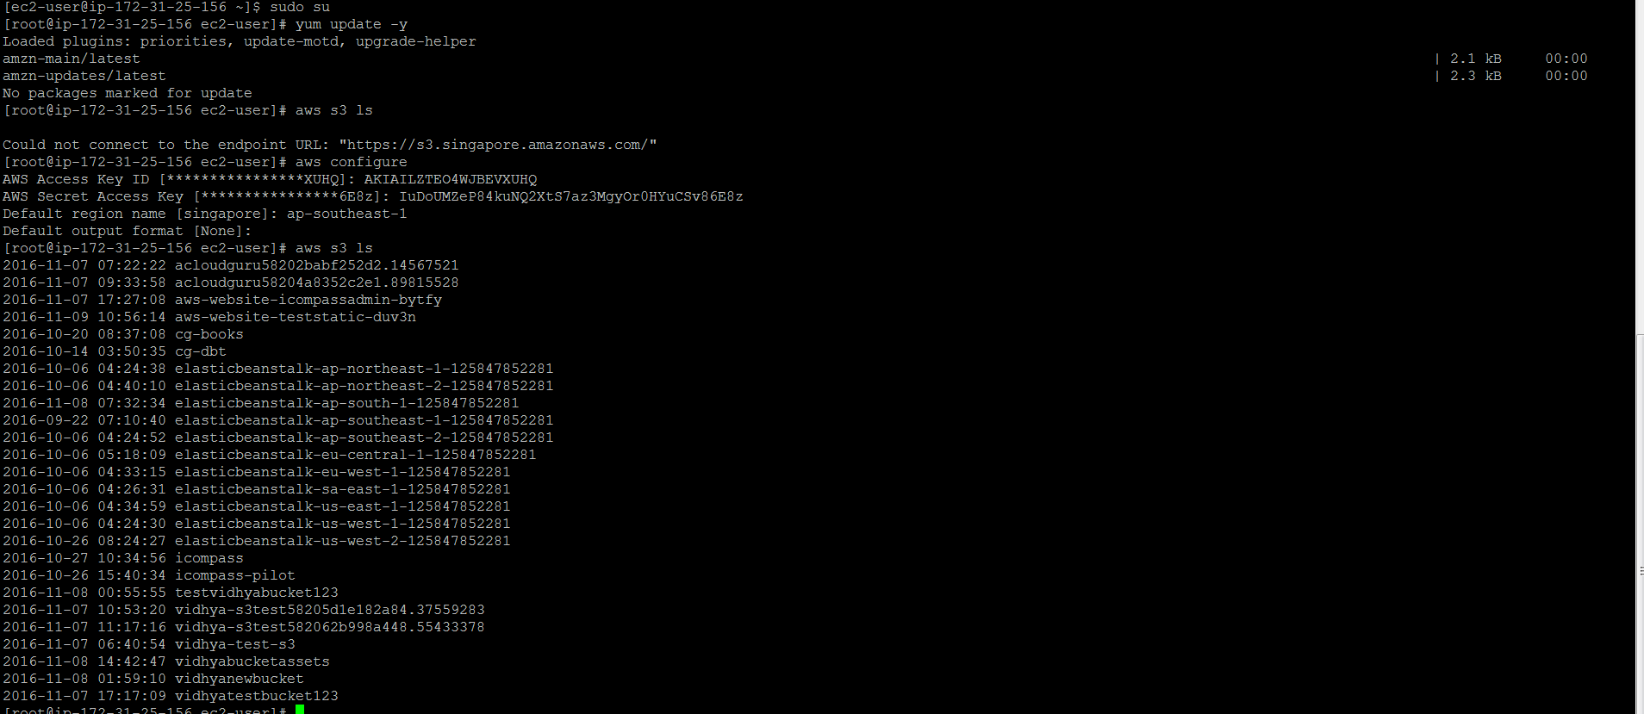

**Once it is done , type aws s3 ls to see the s3 buckets**

**Create a bucket using the command :**

**]aws s3 mb s3://tests3hello**

**]cd /**

**]cd ~**

**]cd .aws**

**]ls**

**Config credentials**

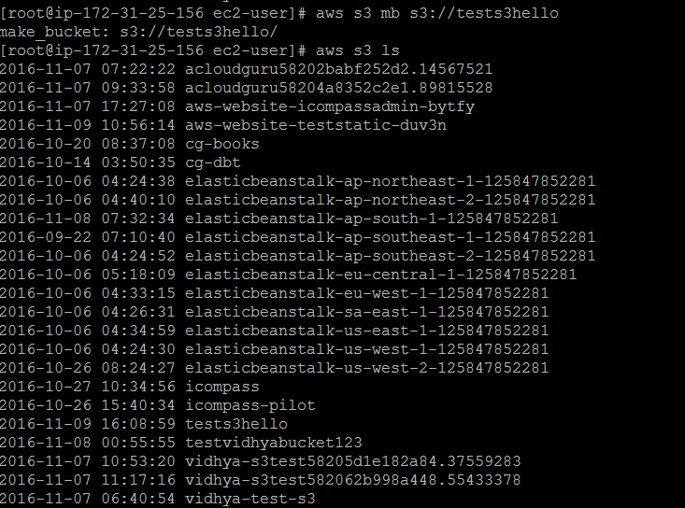

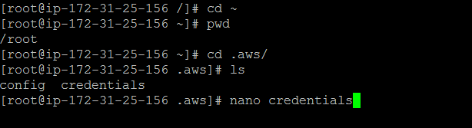

III. **Create a Role and Assigning the Role to EC2 instance**.

1. Create a role called MyS3Access role.

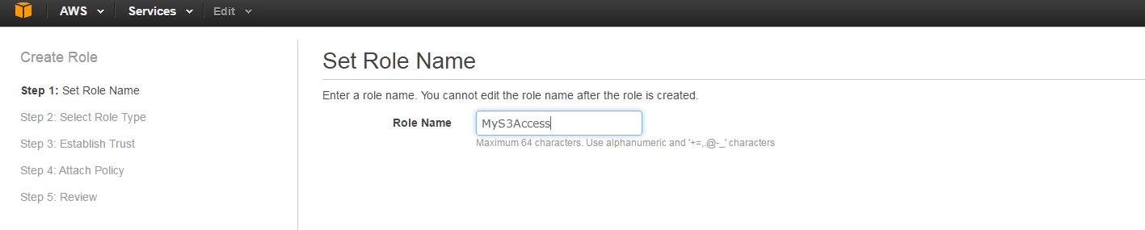

1. Choose Amazon Ec2 Instance type

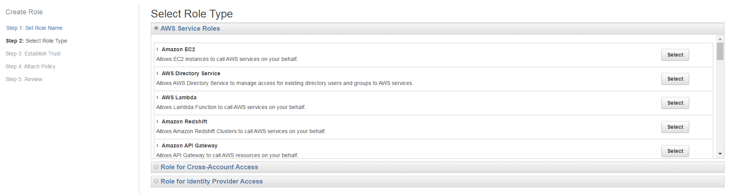

1. Choose AmazonS3FullAccess and click Next

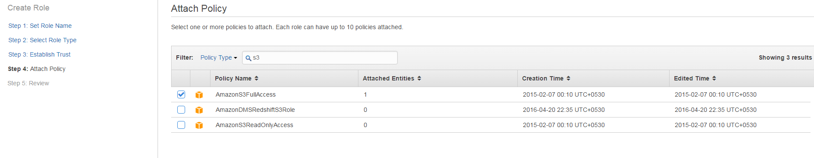

1. Click Review

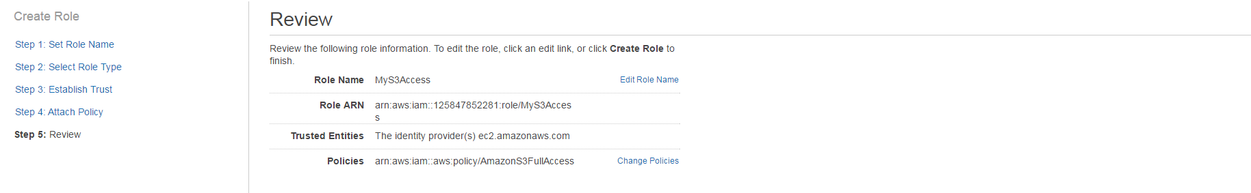

1. Click Create Role

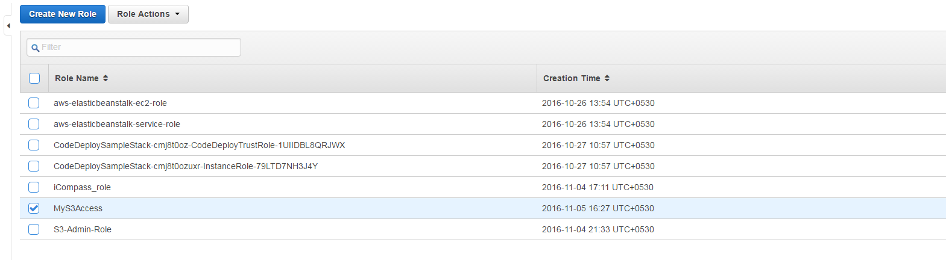

1. Go to Ec2 and launch a new instance.

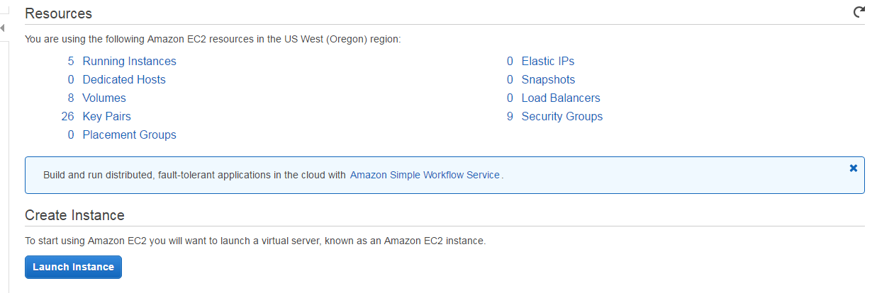

1. Select the Amazon Linux AMI.

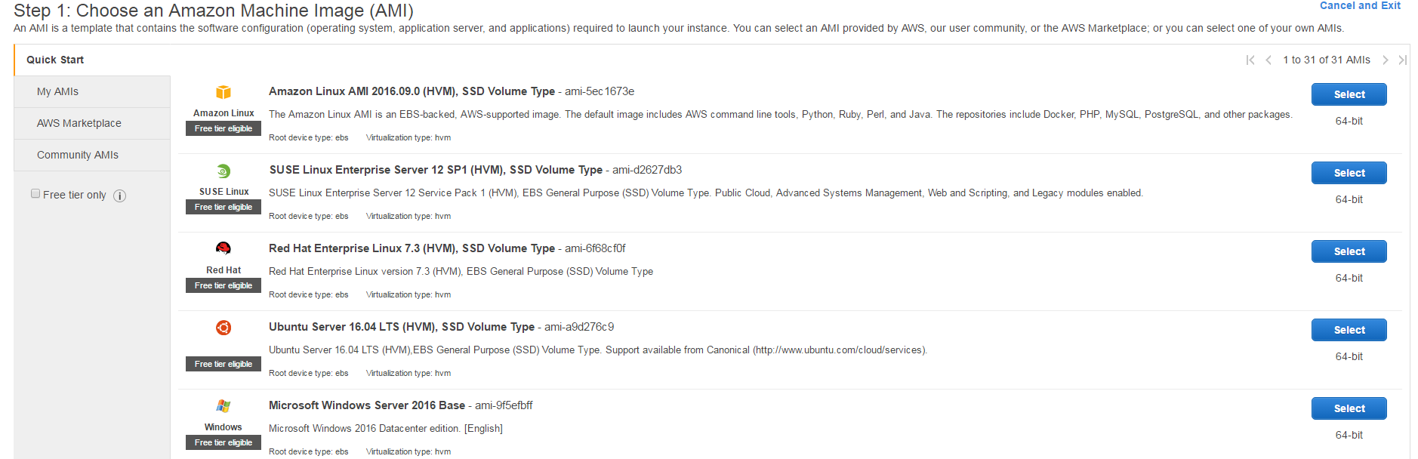

1. Choose instance type and click Configure Instance details

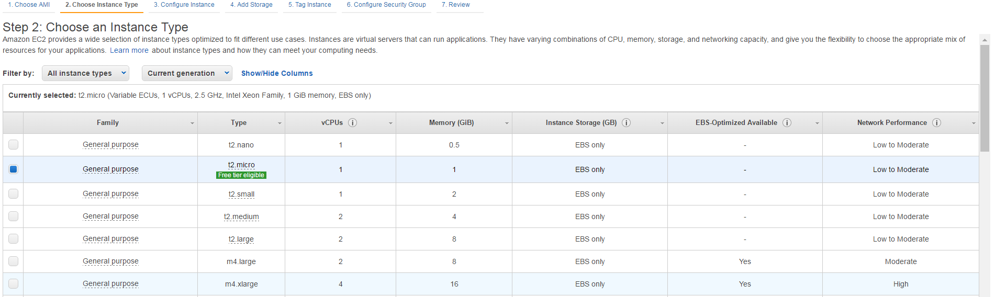

1. Choose MyS3Access Role and click Next : Add Storage

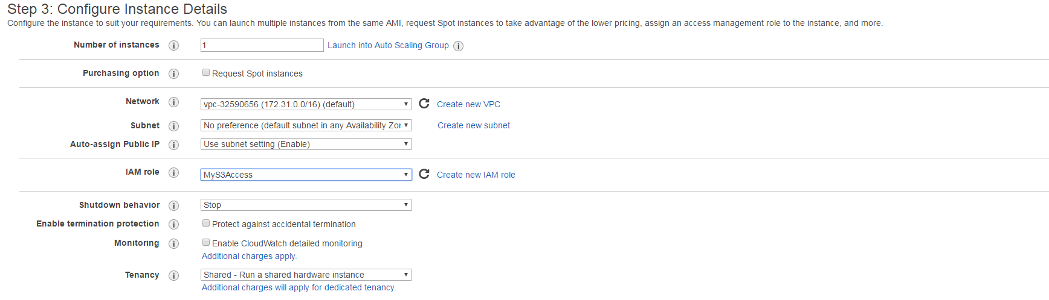

1. Click on Next Tag instance and next : configure Security Groups

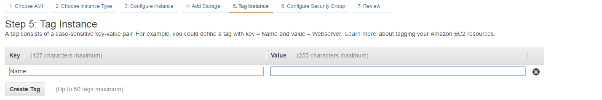

1. Choose Existing security group :

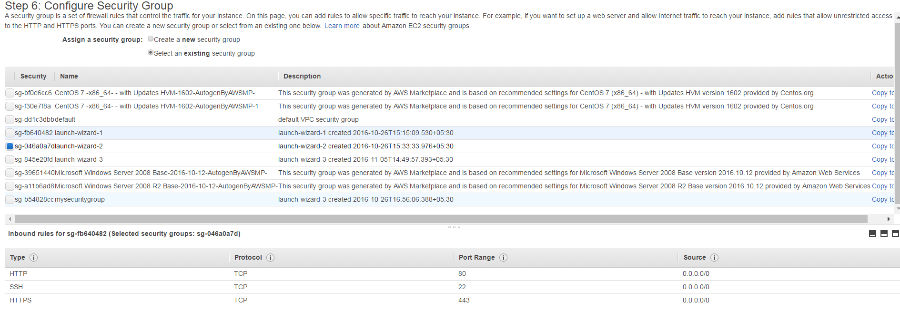

1. Click Review and launch and click launch

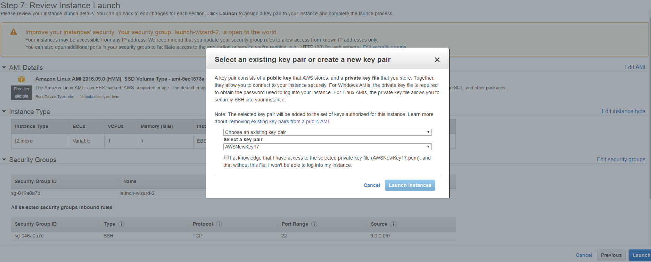

1. Click Launch Instances

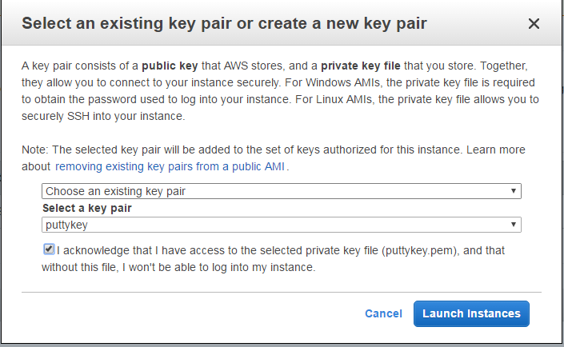

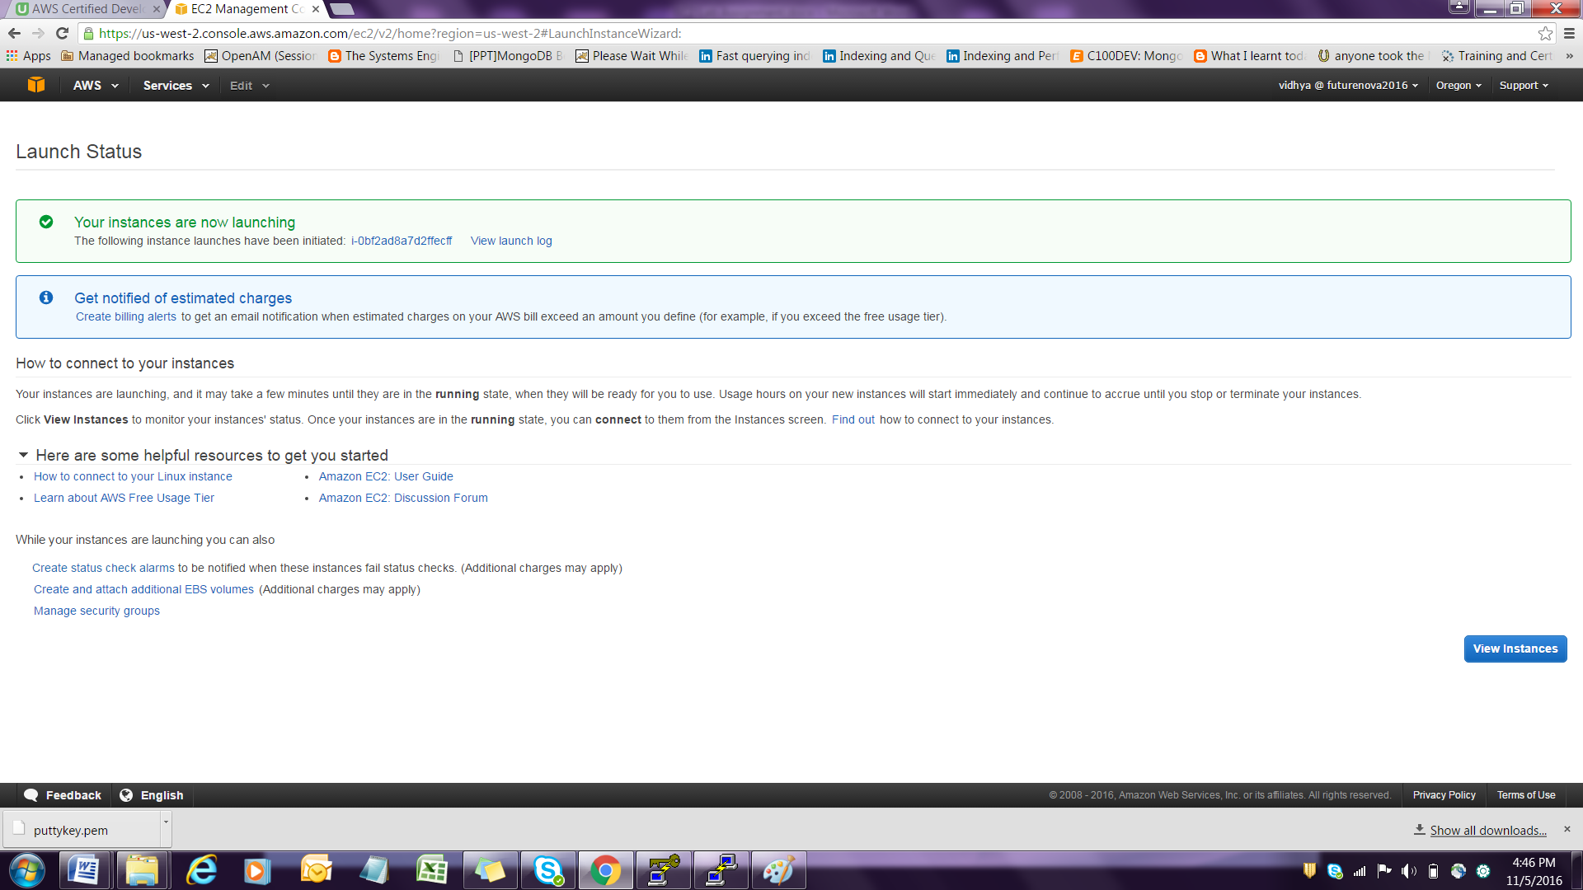

1. To see the EC2 instance up and running

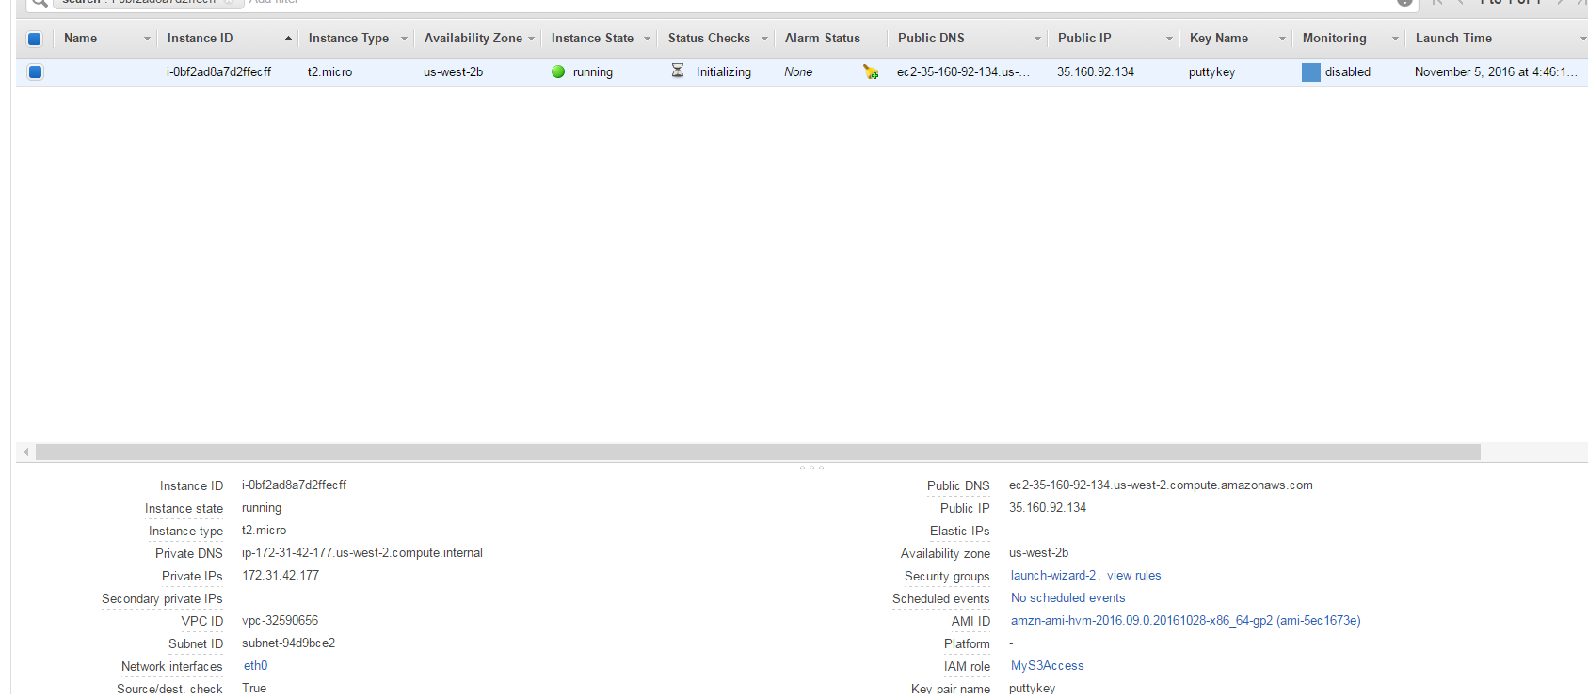

1. Open Putty and type ec2-user1@ [ec2-user1@35-161-155-12(IP](mailto:ec2-user1@35.160.92.134(IP) of new instance) created .
2. Click on SSH 🡪 Auth -> Browse -> choose puttykey.ppk file and then load and open

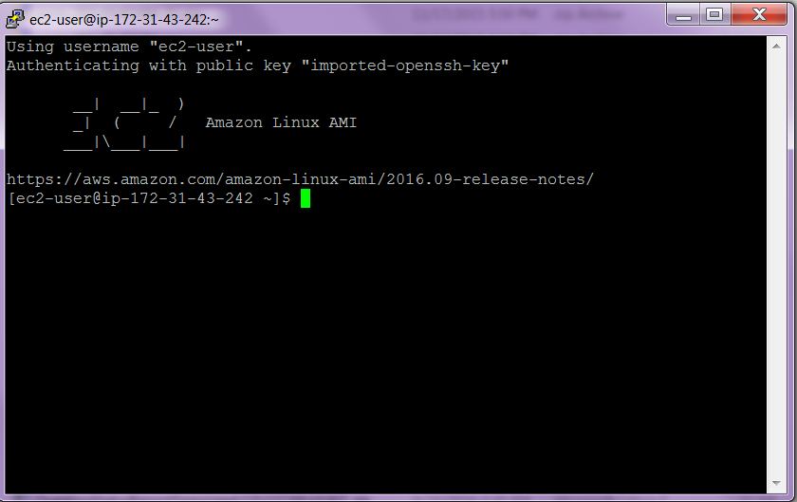

1. Type sudo su

] aws s3 ls

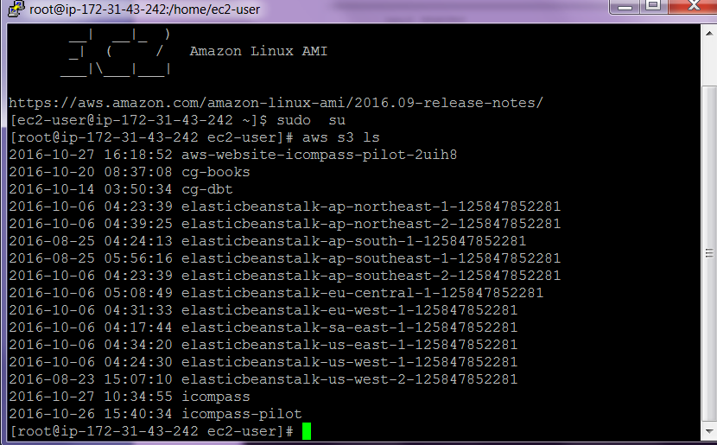

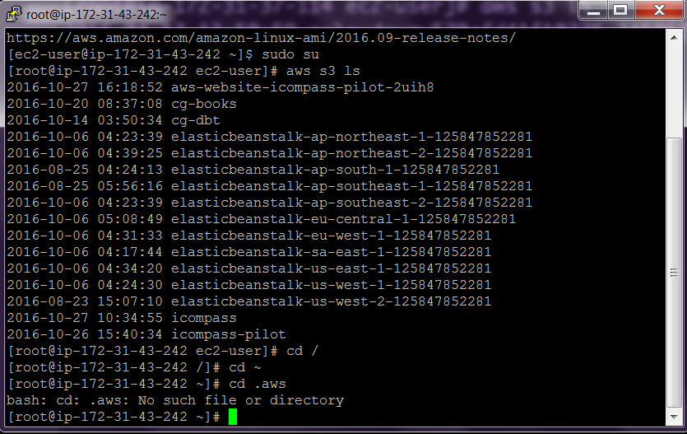

IV . Set up a PHP script

1. **Download the bootstrap script s3bootstrap.sh**
2. **Launch a new instance as before.**

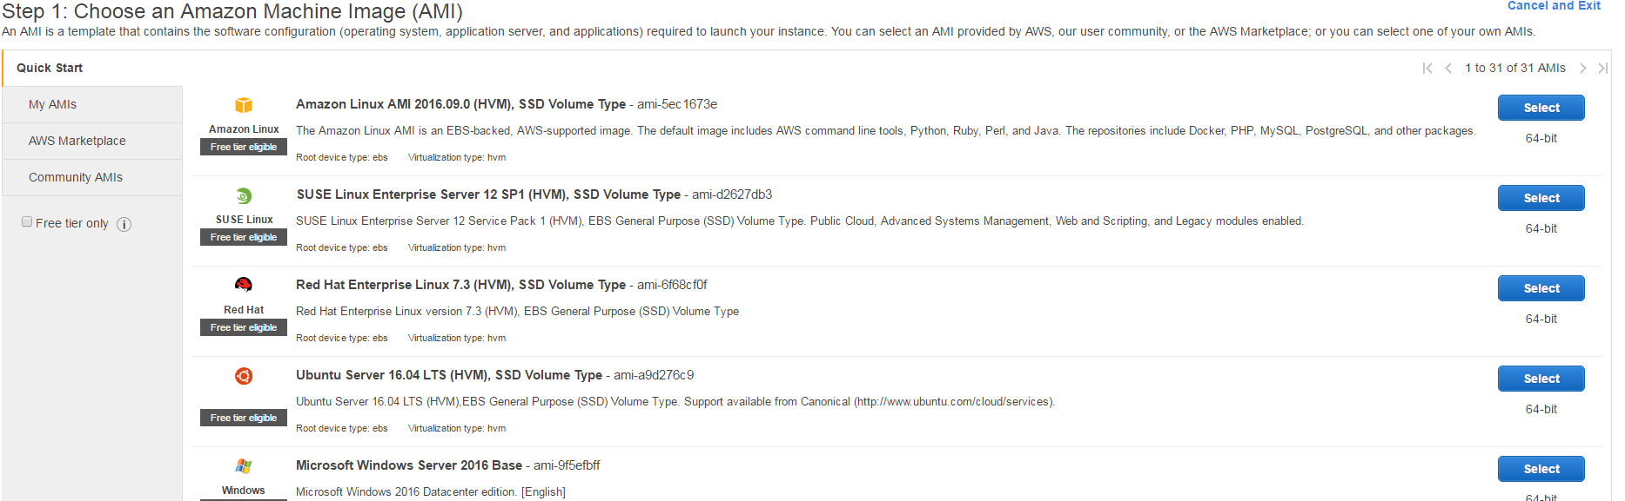

1. **Choose an instance type and click configure Instance details**

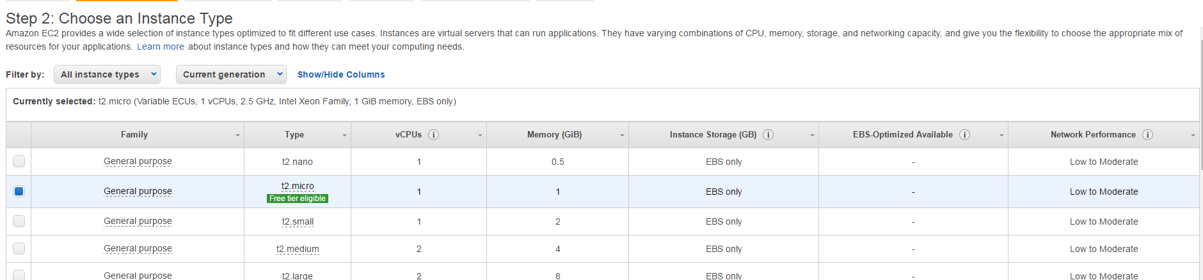

1. **Choose S3-Admin-Role under IAM Role , and copy the bootstrap.sh script in the advanced option and then click add storage**

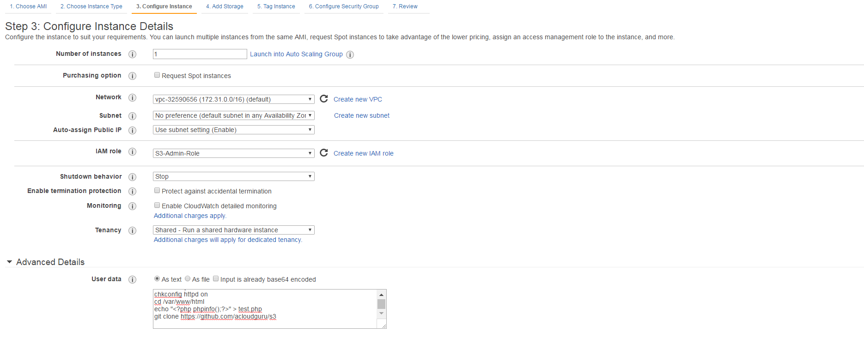

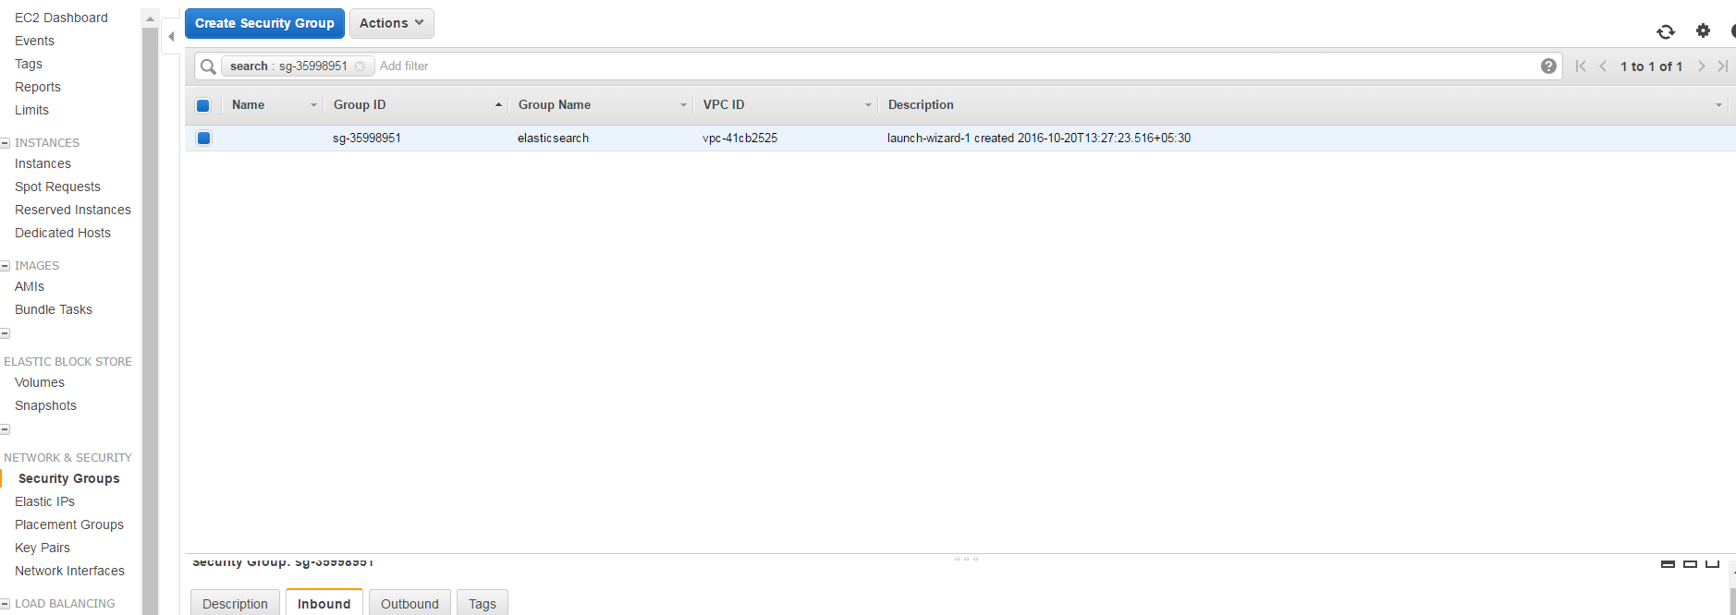

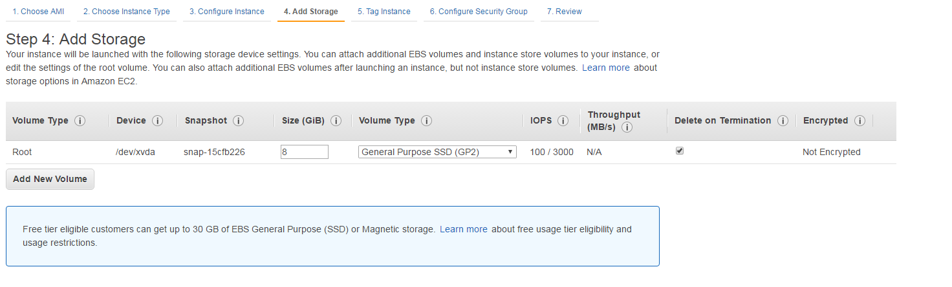

1. **Add** **the tag instance and give a name as php-sdk-ec2 and click Configure Security group**

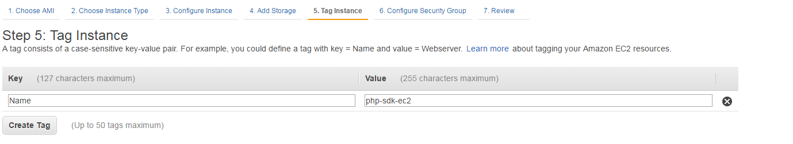

1. **Choose the existing Security group and click review and Launch**

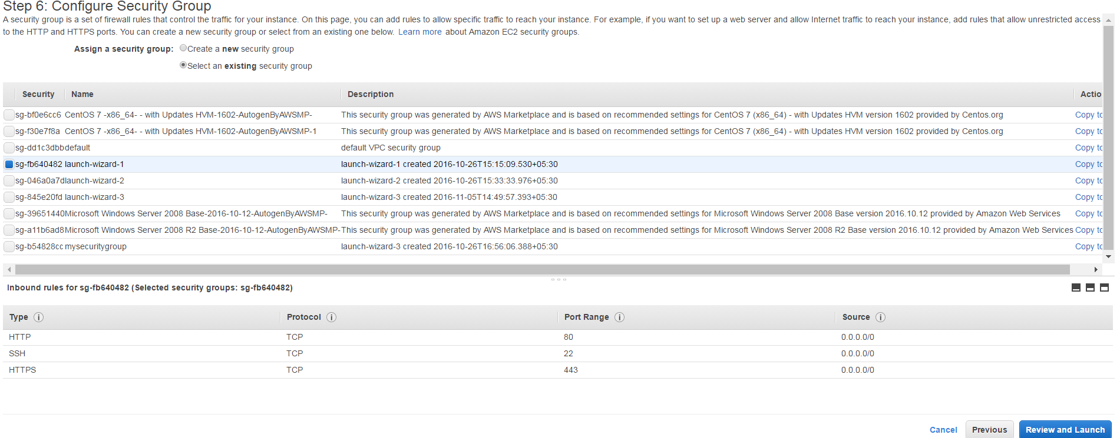

1. **Review Instance Launch**

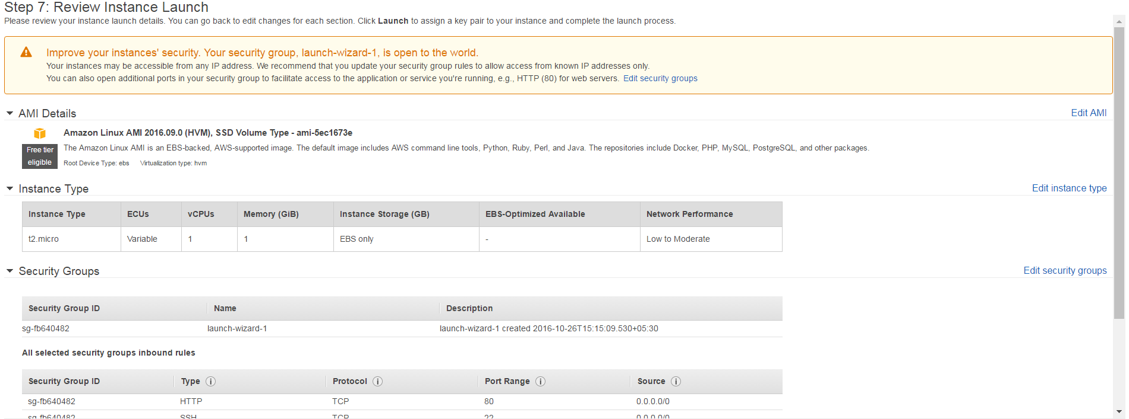

1. **Choose Existing key pair**

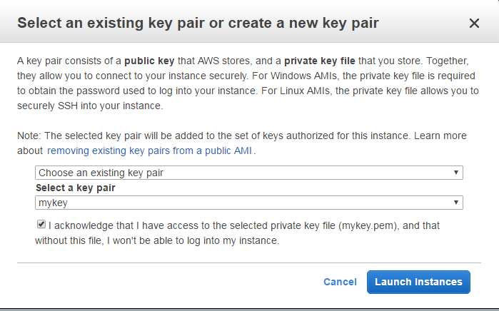

1. **Click launch Instances**
2. **View the instances**
3. **Select the public IP address 35.161.233.141 and open a browser and type 35.161.233.141/test.php**

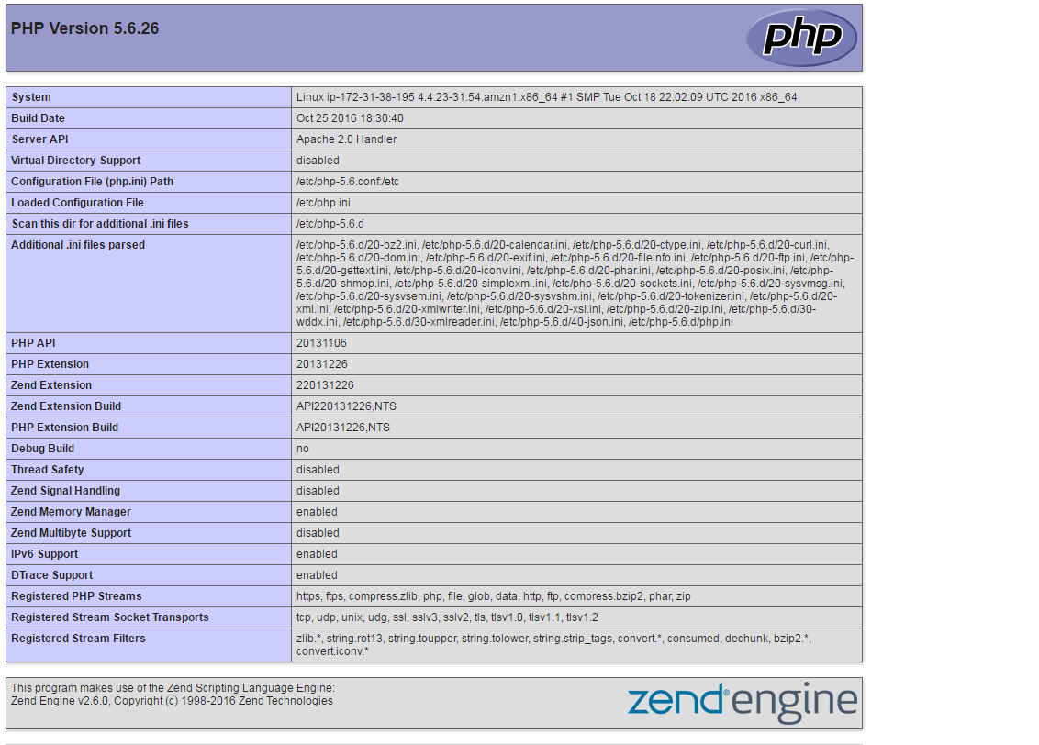

1. **Open Putty set the ip i.e** [**ec2-user@35.161.31.234**](mailto:ec2-user@35.161.31.234) **and choose SSH 🡪 Auth -🡪 Browse -🡪 Choose Puttkey.ppk file and load and open the command line and execute the following commands .**

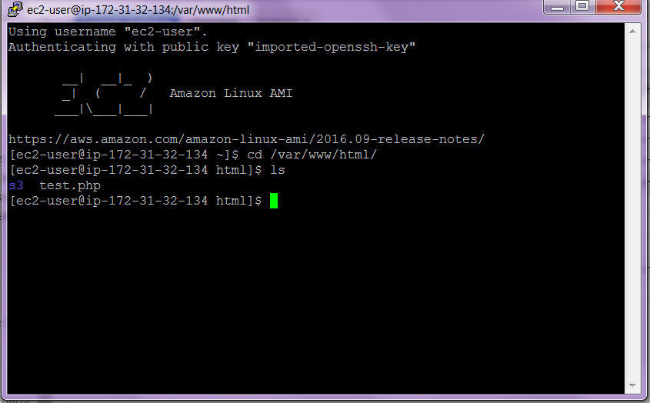

1. **Open a browser and type aws php sdk**

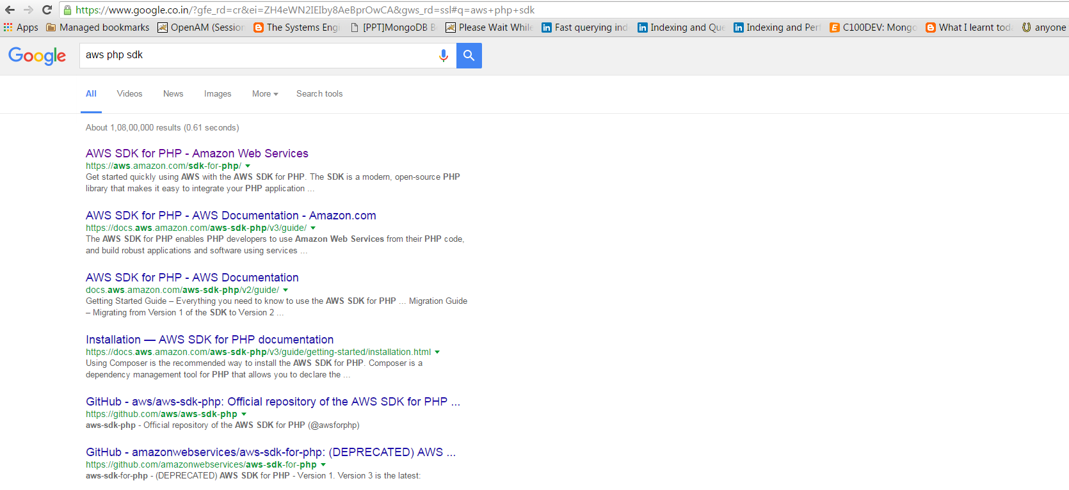

1. Click on the first link so that the AWS SDK for PHP is available

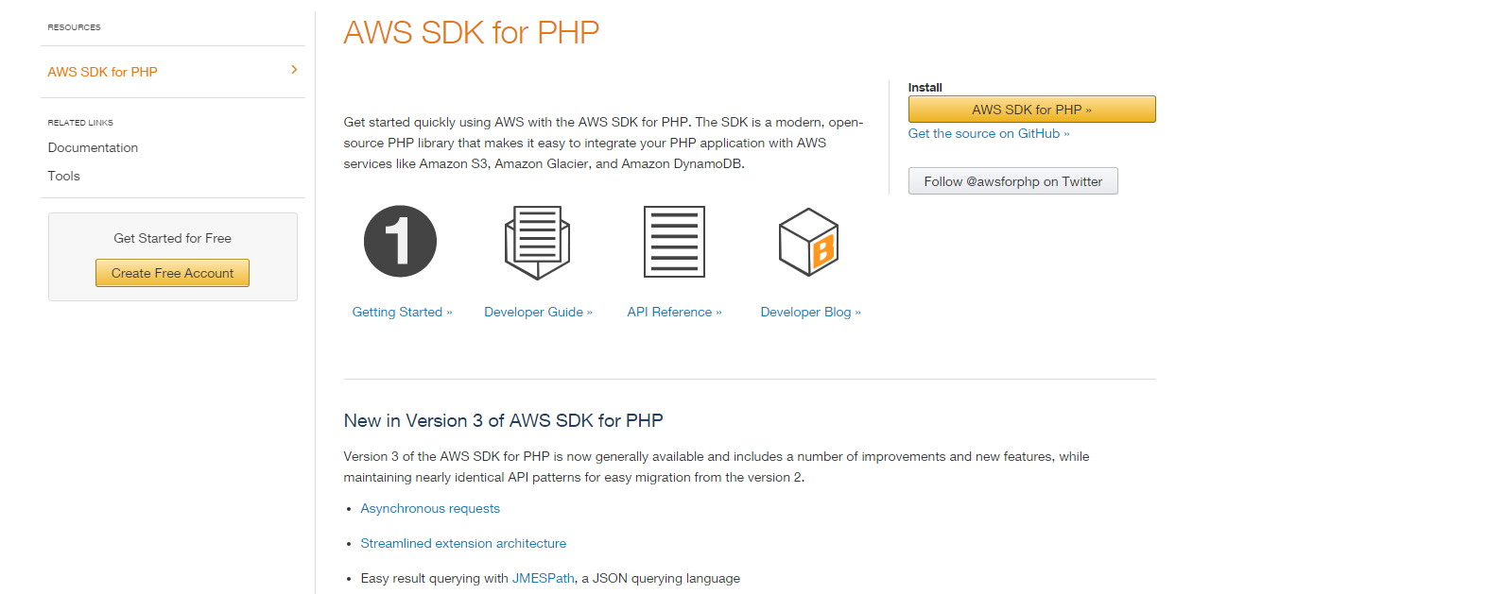

1. **Installing PHP via Composer**

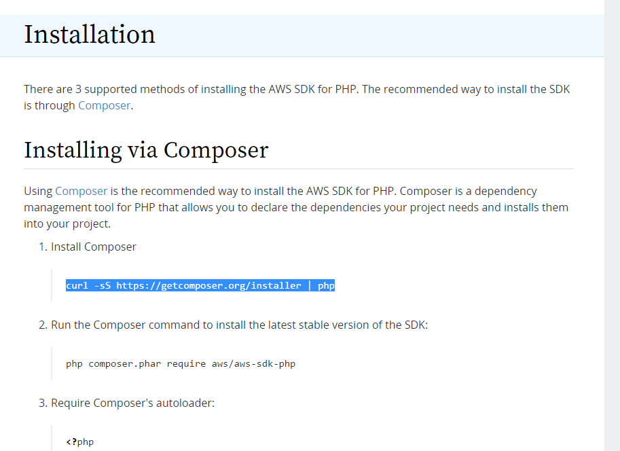

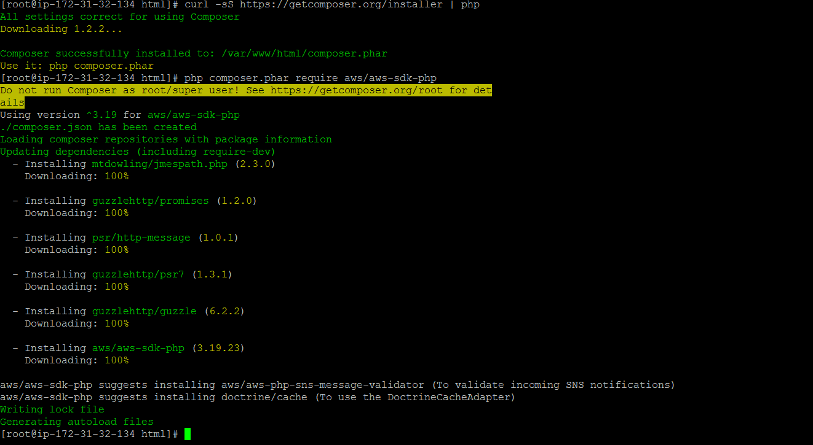

**Execute the Commands as given below**



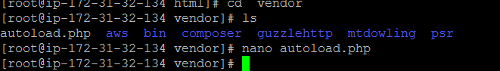

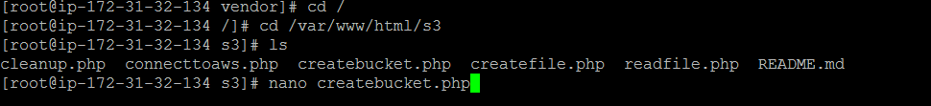

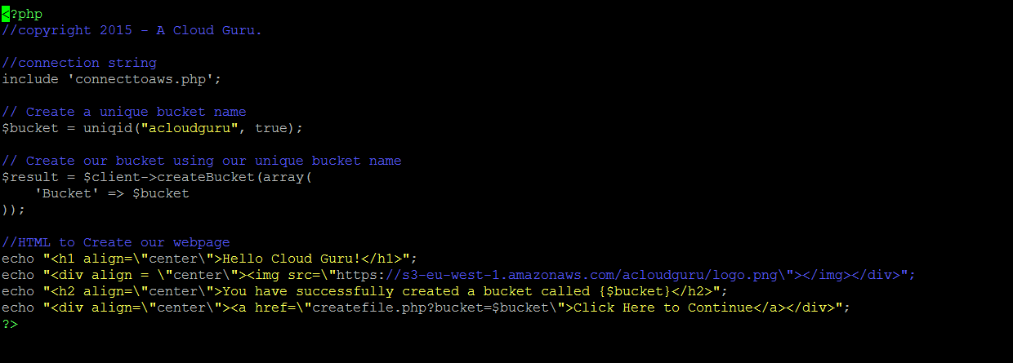

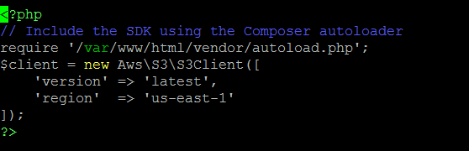

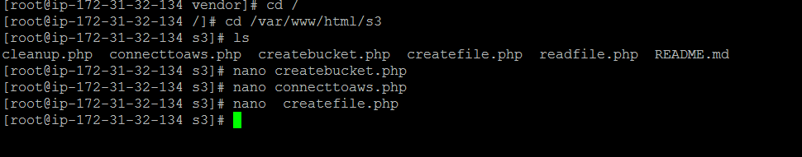

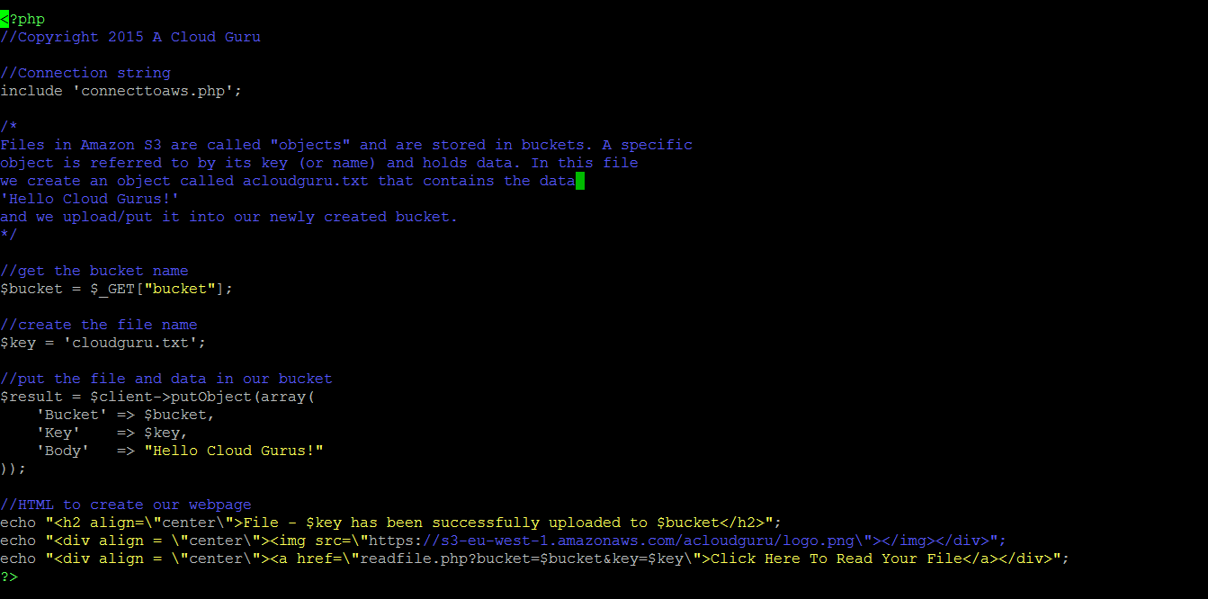

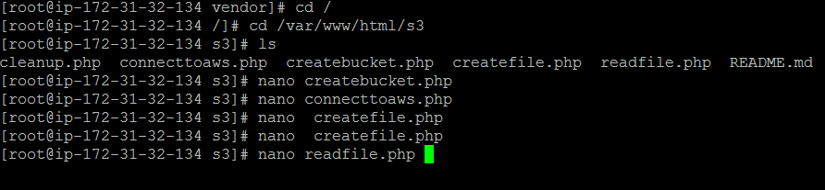

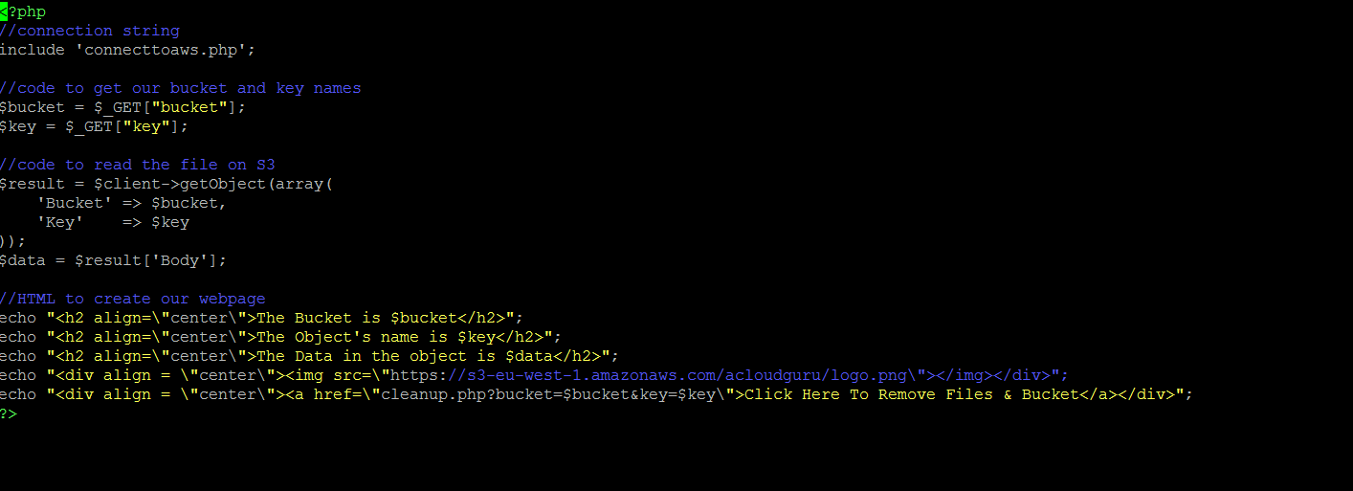

Create a bucket in S3 in AWS console.



Upload a file named w3schools in the bucket created above. Set the permissions as public. Choose properties and note the url created.

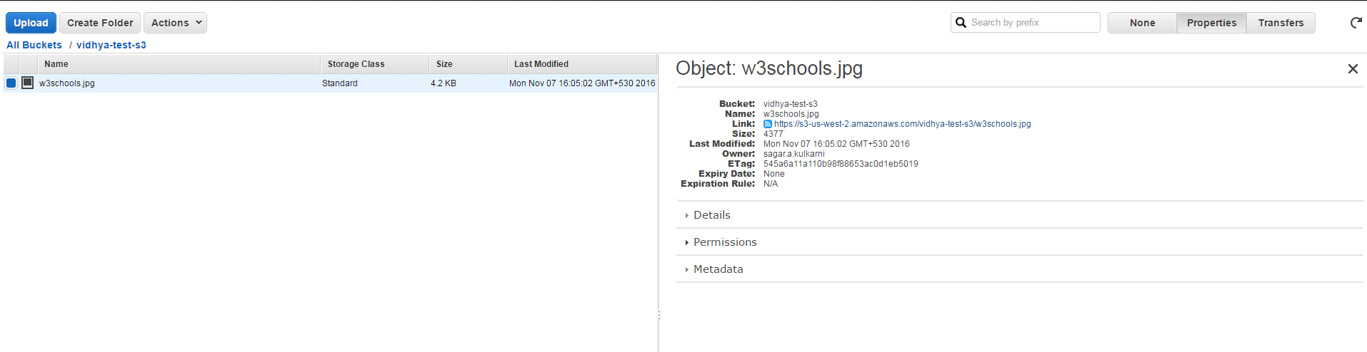

<https://s3-us-west-2.amazonaws.com/vidhya-test-s3/w3schools.jpg>

Make corresponding changes in createbucket.php, connections.php, createfile.php and readfile.php

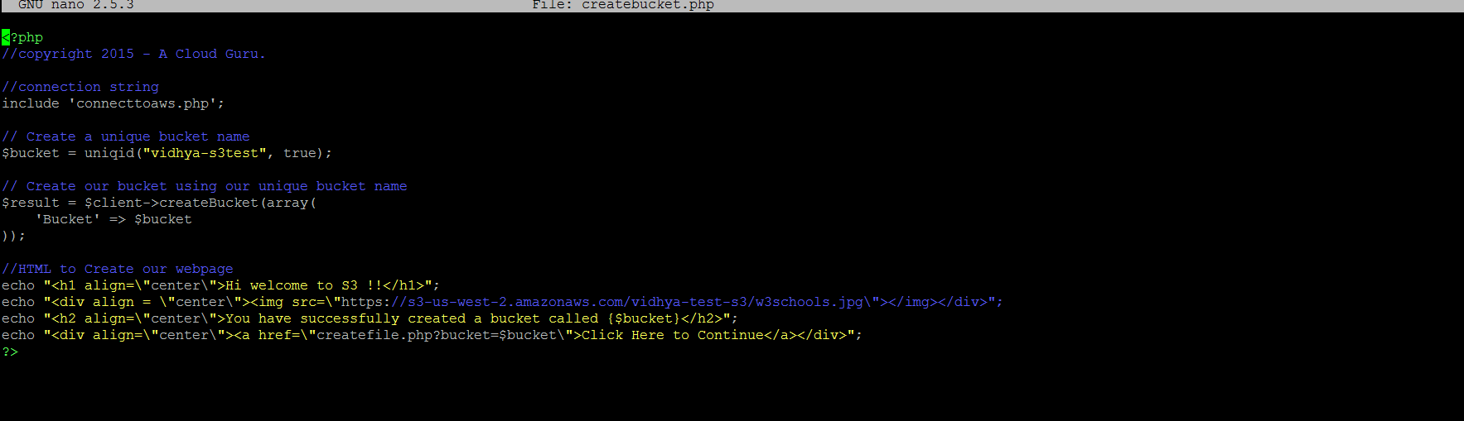

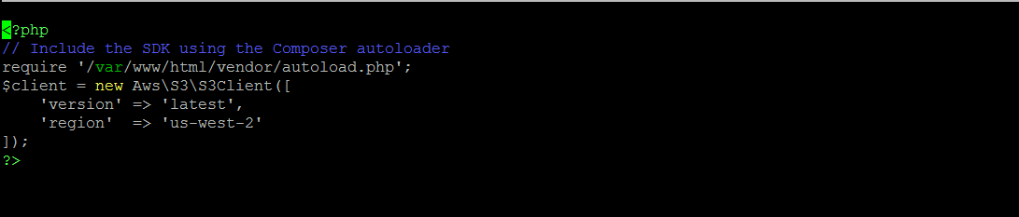

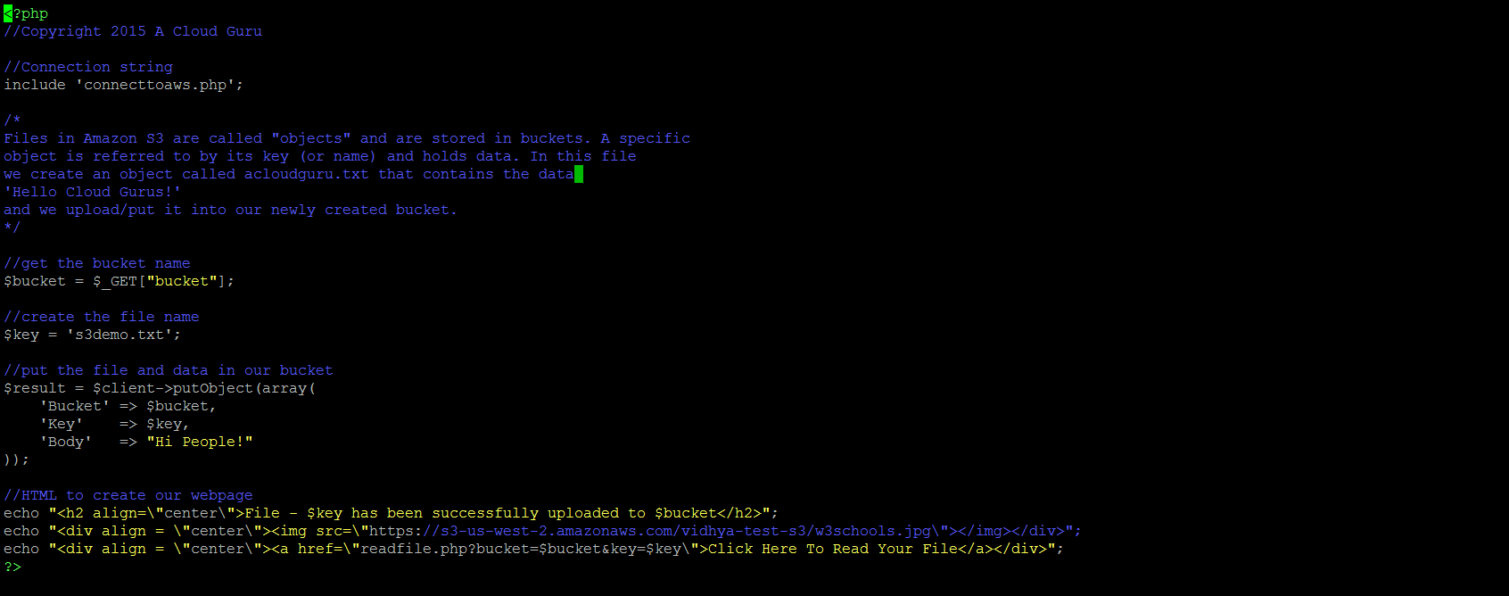

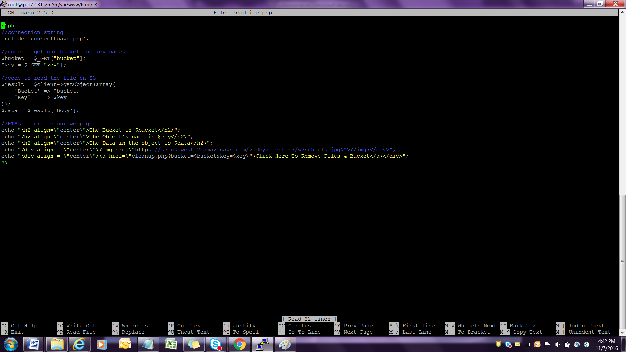

Open the Browser and type the ip :http://54.255.161.58/s3/createbucket.php



Click on click here to continue to see

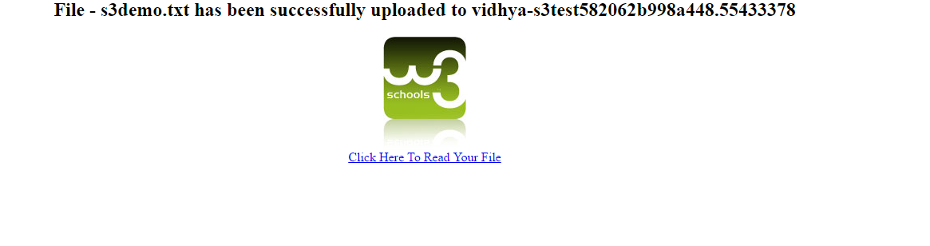

Click the link to read the file as given below



**Elastic Load Balancer**

**Choose Load Balancer from EC2 and proceed.**

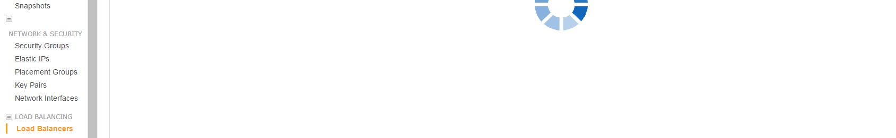

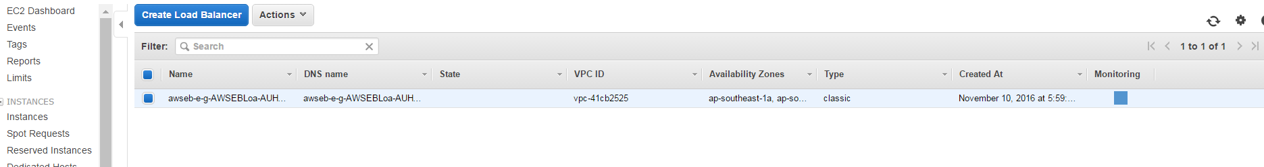

**Choose Application Load balancer**

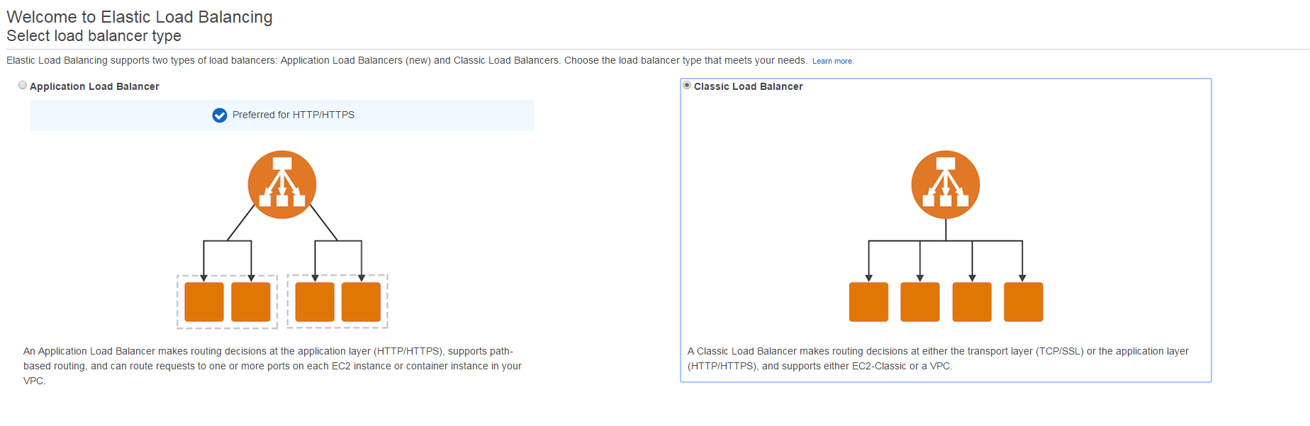

**Set the name for Elastic Load balancer and configure the port as 8080 for HTTP and click next**

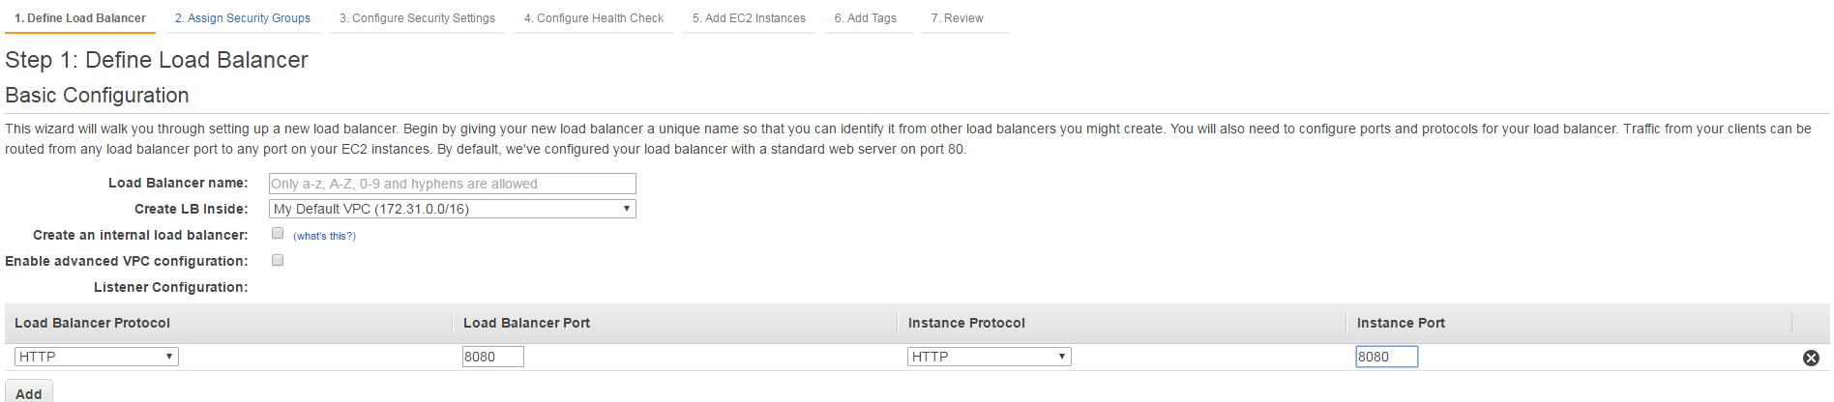

**Assign Security groups**

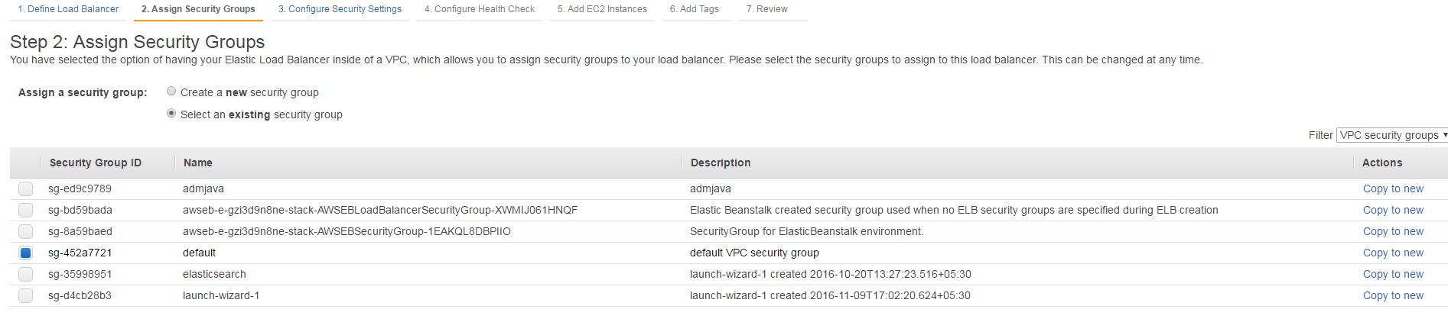

**Click Next**

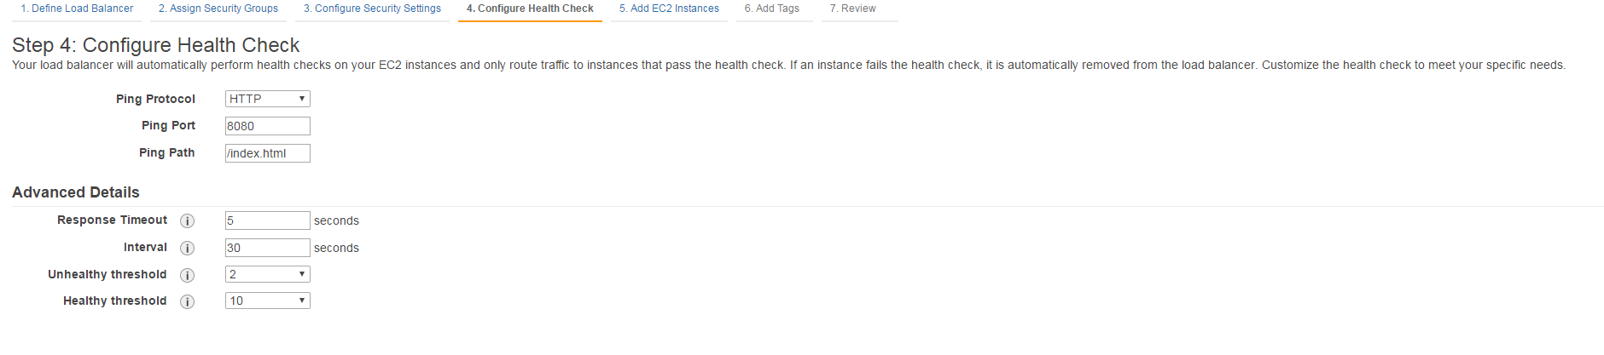

**Add Ec2 instance**

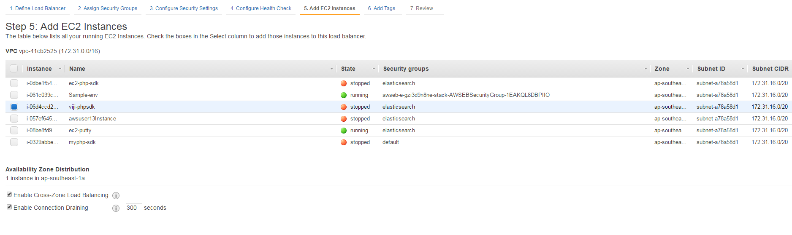

**Set the tag with Key value**

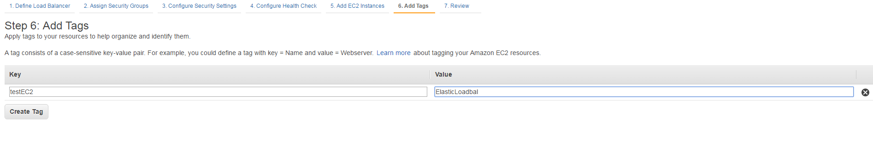

**Click review and create**

